

Post-General Election 2016 Report – Part 1

***Published by the TCI Integrity Commission***

**June, 2017**

# Executive Summary

This is part 1 of a two - part report by the Integrity Commission (the Commission) on the campaign financing and related activities of political parties and candidates during the general elections which took place in December 2016. This report focuses on the registration process and donations received by the Political Parties and Independent Candidates. It also gives an overview of the regulatory controls under the Political Activities Ordinance (the Ordinance) and how these were managed and administered by the Commission. In addition, it briefly covers the Commission’s role in relation to constitutional notice requirements.

Generally, the Commission found that the older political parties had a fairly good understanding of the reporting requirements under the Ordinance. There was remarkable improvement in the quality and regularity of their statutory returns, so there was no formal breaches of the Ordinance. The Independent Candidates and the new Political Party had a steep learning curve to come to grips with the reporting requirements. This was particularly true for the Independent Candidates on whose shoulders the full responsibility of adhering to the Ordinance squarely rested. Having said that however, they too performed admirably well in meeting the deadlines set by the Commission.

Transparency is a key principle that underpins the Ordinance and enables the public to have an understanding of where parties and candidates get their funds and how they spend them. Public confidence in the integrity of the political process is therefore the bedrock of a sound and healthy democracy in the Turks and Caicos Islands. We hope this report will contribute to such confidence and so encourage greater participation in the democratic process.

# Introduction

The Ordinance came into force on 28 August 2012 and provides for the registration and regulation of the conduct of political parties. In March of 2016, an amendment to the Ordinance, brought the Independent Candidates under the same rules which govern the Political Parties in relation to their financial activity and reporting requirements.

The Commission does not have responsibility for nomination of candidates, the conduct of elections or matters connected thereto. These fall within the remit of the Supervisor of Elections, another constitutional Institution that protects good governance. Thus, allegations of *treating* during the election campaign period, for example, were matters for the Supervisor of the Elections and he addressed them, and where necessary, in consultation with the Attorney General’s Chambers and or reported to the Police. However, all Political Party candidates and all Independent Candidates were required to give notice to the Commission, prior to being nominated to run in a General Election, of any and all contracts they may have with the TCI Government. All candidates concerned, commendably complied with this constitutional requirement.

# The Registration Process

**Parties:**

The Commission is required, under Section 3 of the Ordinance, to establish and maintain a Register of Political Parties. In order to contest an election as a political party in the 2016 General Election, a party which was not on the Register of Political Parties from 2012, was required to formally submit an application to register with the Commission prior to the election and to meet the registration requirements of the Ordinance. Only candidates nominated by a Registered Party could stand for election in the name of that party.

Three Political Parties were registered and contested the 2012 General Election. Of this number, one party, the People Progressive Party (PPP) was struck off the Register of registered parties on the 26th February, 2016. However, a new party, the Progressive Democratic Alliance (PDA) was formally registered with the Commission on the 10th September 2015 and was added to the Register of Registered Political Parties as #RP004.

The registered political parties which contested the 2016 General Election were:

* Progressive National Party PNP #RP001
* People’s Democratic Movement PDM #RP002
* Progressive Democratic Alliance PDA #RP004

Particulars of these parties are held and maintained by the Commission in the Register of Political Parties and available for public inspection at the Commission’s offices.

**Independent Candidates:**

In addition to political parties, the amendment to section 68 of the Ordinance in March of 2016 required the Independent Candidates to also register with the Commission. The deadline for their registration application was no later than five days from the date of the Election Proclamation. On registering with the Commission, all prospective Independent Candidates had to also file with the Commission any and all donations received and expenditure incurred by them for the previous 365 days. Ten candidates registered and contested the 2016 General Election. Out of this number, three (3) registered as electoral district candidates, while seven (7) registered as All-Islands candidates.

# Campaign Donations

In relation to donations, no limit had been set in the Ordinance on how much a Political Party or an Independent Candidate could receive in donations. The Ordinance does however limit the amount that can be received from an individual donor within a twelve month period to $30,000. In relation to donations received, Treasurers of the Political Parties and Independent Candidates must check that all donations over $150 are from a permissible source; the Ordinance sets out who are permissible donors. Under the Ordinance, all Political Parties are required to publish all donations which exceed $3,000. In accordance with 24(15) of the Ordinance, the Governor in consultation with the Commission, prescribed in a legal notice, how this should be done.

Political Parties and Independent Candidates were required to submit weekly donation reports to the Commission during the election period following the proclamation of the General Election. The three main political parties received a combined total of $576,708 in campaign donations. The table below sets out the total amount of donations received by the parties based upon the weekly reports submitted and reported to the Commission during the election period between November and December 2016.

|  |  |  |  |
| --- | --- | --- | --- |
| **Party** | **Election Period covered** | **Total donations received** | **% of total by all parties** |
| Progressive National Party | November 2016-December 2016 | $268,798 | 47% |
| People’s Democratic Movement | November 2016-December 2016 | $297,142 | 52% |
| Progressive Democratic Alliance | November 2016-December 2016 | $10,769 | 2% |

In addition, parties are also required, under the Ordinance, to submit bi-annual donation reports for the periods January - June and July – December of each year. Parties also have to file Annual Statements of Accounts with the Commission. The year runs from 1st April to 31st March. These are due by 31st July or 30th September depending on income and expenditure being above or below $500,000. The Commission will be working with the parties in the months ahead to ensure these reports are compiled and submitted accordingly.

The total donations to Independent Candidates based on their weekly reports totaled $129,353.

*A detailed and analytical report of the campaign donations as reported by the two groups, as well as the full comparison between the two groups and in relation to their statutory expenditure limit are set out in* ***Appendix I*** *to this report.*

# Campaign Spending

**Parties:**

Spending by political parties and Candidates during the election period has also been regulated by the Ordinance and there is a maximum that each party or candidate can spend. In accordance with Section 46(8) of the Ordinance, the limits are as follows:

* $30,000 in relation to each electoral district contested by the party (of which there were 10)
* $40,000 in relation to the all-islands district (of which there were 5)
* $100,000 in relation to each of the parties leaders or the all-Islands Independent Candidates

It was therefore possible for each party to spend a total of $600,000 on their respective campaigns. All political parties that put forward candidates for the 2016 General Election have to submit a campaign expenditure return. If their expenditure was under $250,000 the report had to be filed with the Commission within three months of the General Election. If however their campaign spending was $250,000 or more the report has to be audited and submitted with an Auditor’s Report to the Commission within six months from the General Election date. Two parties have informed the Commission that their expenditure exceeded $250,000 and as such will file their Expenditure Returns to the Commission by the 15th June 2017. The remaining party whose expenditure did not exceed $250,000 has submitted its expenditure return to the Commission as required. Once the Commission has received all expenditure returns, it will compile a separate and detailed report of campaign spending by the political parties and independent candidates. This will form Part 2 of the Post-Election 2016 Report and will be published in July 2017.

**Independent Candidates:**

Independent Candidates were required to submit a record of their donations and all expenditure incurred by them during the election period after the General Election. Ten Independent Candidates stood for the December 2016 General Elections. These were:

* Michael Missick
* McAllister Hanchell
* James Hudson Parker
* Damian Wilson
* Clarence Selver
* Jasmin Salisbury Walkin
* Sabrina E Green
* Oscar O’Brien Forbes
* Valerie Beatrice Jennings
* Courtney Mancur Missick

As with Political Parties, there was no limit on how much an Independent Candidate can receive in donations. However, the $30,000 maximum per individual donor applied.

The spending restrictions on the Independent Candidates were as follows:

Spending limit for All-islands Candidates was $100,000 per candidate and $30,000 for each electoral district Candidate. Three Independent Candidates ran in specific constituencies whilst the remaining seven ran as All Island Candidates. The Commission has received expenditure records from all independent candidates.

# Advice and Guidance

With the larger slate of Independent Candidates and a new Political Party, the Commission remained committed to securing compliance by assisting the parties, their Treasurers and Independent Candidates to understand the requirements of the Ordinance and to get it right from the outset as opposed to having to take enforcement action in the event that wrong steps were taken.

To achieve this, the Commission proactively provided guidance notes to help achieve clarification and compliance in key areas during separate face to face engagements with the Independent Candidates and all Treasurers and executive members of the three Political Parties for several months leading up to the General Election. As was previously done in the 2012 General Election, the Commission drafted and circulated guidance notes to all Political Parties and all Independent Candidates on the following areas:

* Guidance note on the Registration Process;
* Guidance note on Donations;
* Guidance note on Corporate Donations and Dormant Companies;
* Guidance note on Loans, how these are reported and what constitutes a loan on commercial terms;
* Guidance Note on Campaign Expenditure;
* Guidance Note on Interest in Contracts with Government.

These Guidance Notes were very much part of the process of engaging with the parties and the Independent Candidates and ensuring they understood the rules and regulations. They were issued to assist political parties and candidates to comply with their obligations under the Ordinance. However, the Commission made it clear that the Guidance Notes were not intended to supersede the Ordinance and any Regulations made under it and in the event of any inconsistency, the Ordinance and Regulations would prevail. Party Treasurers and the candidates actively engaged the Commission with queries during the Election period. The Commission thought that this was evidence of genuine commitment and desire to be compliant by the political parties and candidates.

# Constitutional Requirements

The new Constitution of the Turks and Caicos which came into force on 15 October 2012 set out certain qualification requirements for elected or appointed members of the House of Assembly. Section 49 covers disqualifications for elected or appointed members of the House of Assembly. Section 49(1)(f) covers contracts or interests with Government and notice of any such contracts or interests were required to be submitted to the Commission prior to being nominated.

The Commission received responses from all fifty two (52) potential candidates of which there were thirty six (36) such notices and the information submitted was placed in a register of contracts. The Commission subsequently issued a press release and the register was formally published, in accordance with Section 49(3) of the Constitution, on the 22nd November 2016. Prior to doing so, the Commission contacted each individual to ensure the details contained in the register accurately reflected their position in relation to contracts and interests with government.

The Commission therefore met its constitutional obligation under Section 49(3) to publish any notice delivered to it under subsection (1) (f) for the purpose of informing the electorate before the date of election.

# Persons in Public Life

All elected and appointed members of the House of Assembly are now Persons in Public Life and are therefore subject to the Integrity Commission Ordinance. Under Section 52, every member of the House of Assembly shall file with the Commission, in addition to the declaration under Section 39, a Statement of Registrable Interests.

In February 2017, the Commission held a briefing session with all Members of the new House of Assembly who are now subject to making the necessary declarations. This was to assist all in understanding the compliance requirements under the Integrity Commission Ordinance. For most, it was a simple reminder but for new members it was their first interaction with the Commission. Furthermore, on June 8, 2017, the Commission made a presentation of its work and anti-corruption efforts at the post- elections seminar organized by the Commonwealth Parliamentary Association for House of Assembly Members.

# Press and Public Awareness

The Commission felt that engaging with the media was important from the outset. This was to ensure that the public was aware of the work it was doing and also to provide a high degree of transparency in the process of political financing in the Turks and Caicos Islands. All engagements with potential Independent Candidates and Political Parties were open to the media and invitations were sent to all media houses to attend. We will continue to do so as part of the ongoing work of the Commission to keep the public both informed and engaged in the process.

# Closing Summary

The Commission’s work in respect of monitoring the financing of political parties and candidates under the Ordinance is a continuous process. The diligence and commitment to compliance exhibited by both the established Parties and the Independent Candidates is commendable and foundational to further work of the Commission, going forward. The Commission will continue to strengthen the guidance and advice that we provide to support the political parties and candidates in meeting their obligations and so build on

the already enhanced transparency in political financing in the Turks and Caicos Islands. Wherever possible the Commission will continue to use advice and guidance to secure compliance with the Ordinance. We will be looking for opportunities to simplify the rules, and reduce the administrative burdens on parties and others who fall under the jurisdiction of the Commission. We will therefore be working closely with the parties and others in evaluating the work we have done so far and to assess how we may be able to improve the process going forward.

*For more information or any queries on this publication, please contact the Commission at:* [*Deputydirector@integritycommission.tc*](mailto:Deputydirector@integritycommission.tc)*. secretary@integritycommission.tc;*

[Tel:](Tel:nhbjcjcjjdicDJAsskckckmdc) 649-946-1941; 649-338-3335; 649-338-3334

**APPENDIX 1** FOLLOWS

**TOTAL DONATIONS REPORTED**

**Total Donations Reported**

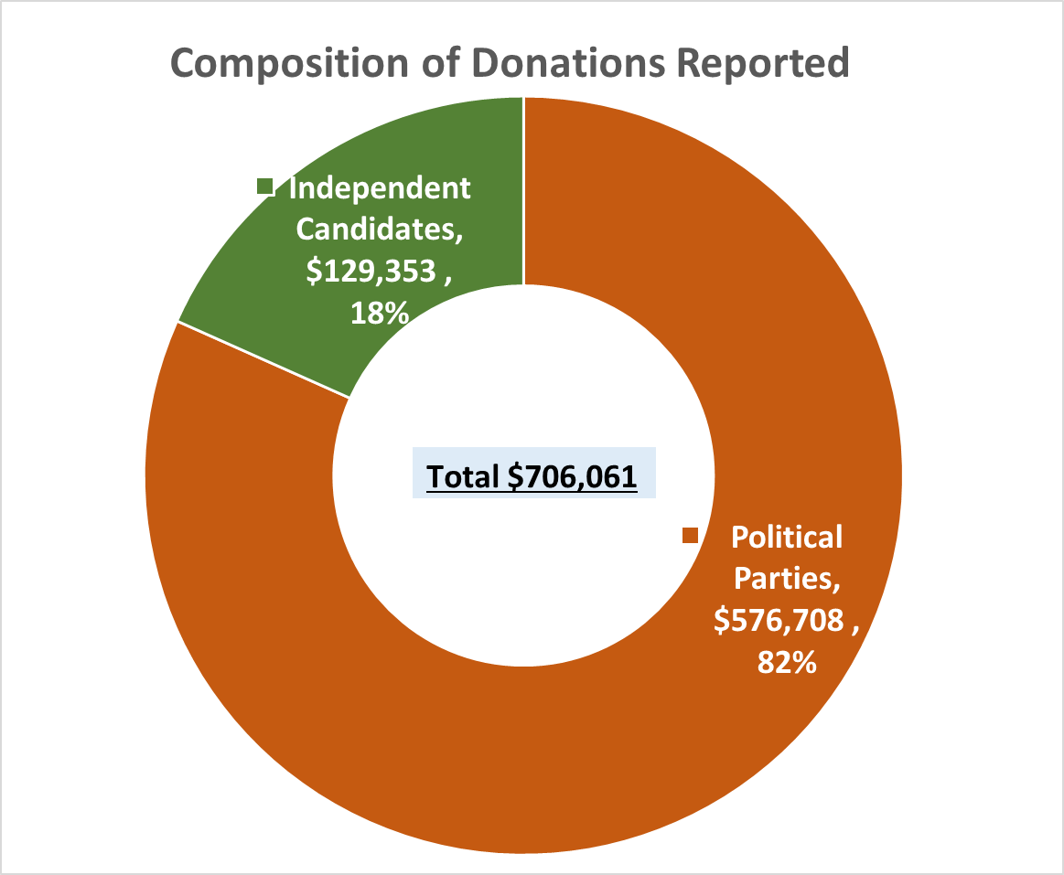

The total donations reported for the December 2016 election amounted to **$706,061.**

The Political Parties accounted for 82% of the donations reported whereas Independent Candidates accounted for 18%. See table and graph below.

|  |  |  |
| --- | --- | --- |
| **Entity** | **Donations** | **(%)** |
| Political Parties | 576,708 | 82% |
| Independent Candidates | 129,353 | 18% |
| **Total** | **$706,061** | **100%** |

**Total Donations Reported versus Legal Expenditure Limit for Political Parties and Independent Candidates**

A comparison of the total donations reported by the Political Parties and the Independent Candidates against the legal expenditure limits was done to **estimate** the potential level of expenditure which could be anticipated based on the donations reported. This comparison is described in the sections below.

The overall expenditure limit for the December 2016 elections was $2,590,000. The basis for determining the overall expenditure limit is as follows.

* The total legal limit for expenditure by each party is $600,000. The maximum combined expenditure permitted for the three (3) parties who contested the December 2016 election would amount to $1.8M. Detailed comparison for each Political Party is shown in the *Donations Reported by Political Parties* section of this report.
* Seven (7) independent candidates were nominated to run in the All Island constituency while three (3) ran in the Individual/District Constituencies. The legal limit for expenditure by each candidate at the All Island Constituency is $100,000 while the expenditure limit at the Individual Constituency is $30,000. The maximum combined expenditure permitted for the seven (7) candidates at the All Island Constituency amounts to $700,000 and $90,000 for the three (3) candidates at the Constituency level.

Detailed comparison for each Independent Candidate is shown in the *Donations Reported by Independent Candidates* section of this report.

-+

The overall reported donations of $706,061 amounts to 27% of the overall combined expenditure limit of $2.6M for the Political Parties and the Independent Candidates.

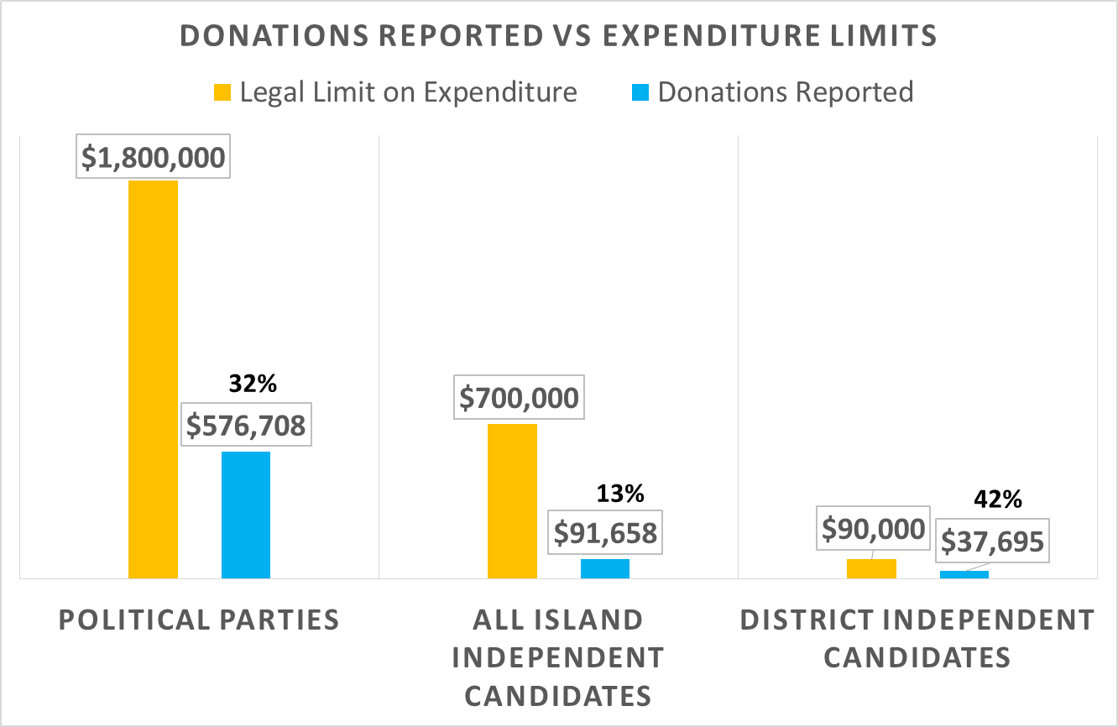

Donations reported by the Political Parties were 32% of the combined legal expenditure limit of $1.8M.

The All Island Independent Candidates reported donations were 13% of the combined legal expenditure limit of $700,000.

The District Independent Candidates reported donations 42% of the combined legal expenditure limit of $90,000. See table and chart below.

|  |  |  |  |
| --- | --- | --- | --- |
| **Entity** | **Legal Limit on Expenditure** | **Donations Reported** | **Donation Reported as a % of Expenditure Limit** |
| Political Parties | 1,800,000 | 576,708 | 32% |
| All Island Independent Candidates | 700,000 | 91,658 | 13% |
| District Independent Candidates | 90,000 | 37,695 | 42% |
| **Total** | **2,590,000** | **706,061** | **27%** |

***NB: The report and analysis of the actual campaign expenditure by the Political Parties and Independent Candidates will be compared to their legal expenditure limit and published, after the receipt of their respective campaign expenditure returns. As required by the Political Activities Ordinance, the campaign expenditure returns in relation to the December 2016 general elections, are expected to be submitted to the Commission latest by June 2017.***

**Composition of Donations: Cash vs Non-Cash**

Of the total donations reported, cash donations represented 90%, while 10% was reported as non-cash. Non-cash donations comprised primarily of - use of services/equipment, donation of actual items, discounts by suppliers or payment for items on behalf of the Political Parties or Independent Candidates.

The Political Parties reported 91% of their donations were in cash, while the Independent Candidates reported 89% as cash. See table and chart below for the composition of donations reported.

|  |  |  |  |  |  |  |
| --- | --- | --- | --- | --- | --- | --- |
| **Entity** | **Cash** | | **Non Cash** | | **Total** | **Total (%)** |
| **$** | **%** | **$** | **%** |
| Political Parties | 523,447 | 91% | 53,261 | 9% | 576,708 | 82% |
| Independent Candidates | 115,444 | 89% | 13,909 | 11% | 129,353 | 18% |
| **Total** | **638,891** | **90%** | **67,170** | **10%** | **706,061** | **100%** |

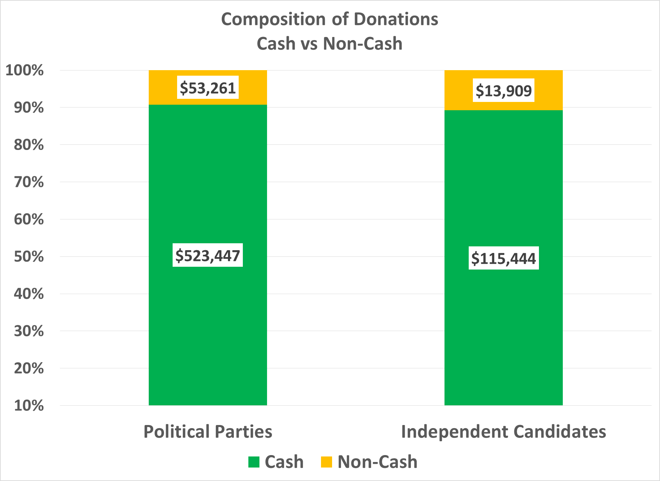

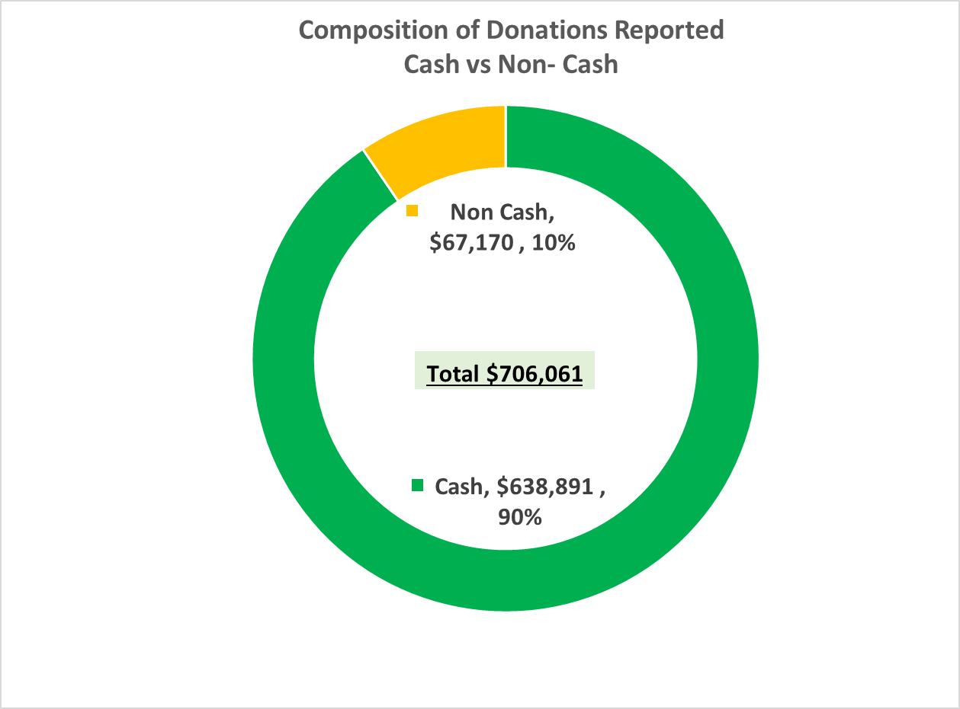

**Donation Sources: Private Individuals, Self-Financed and Companies**

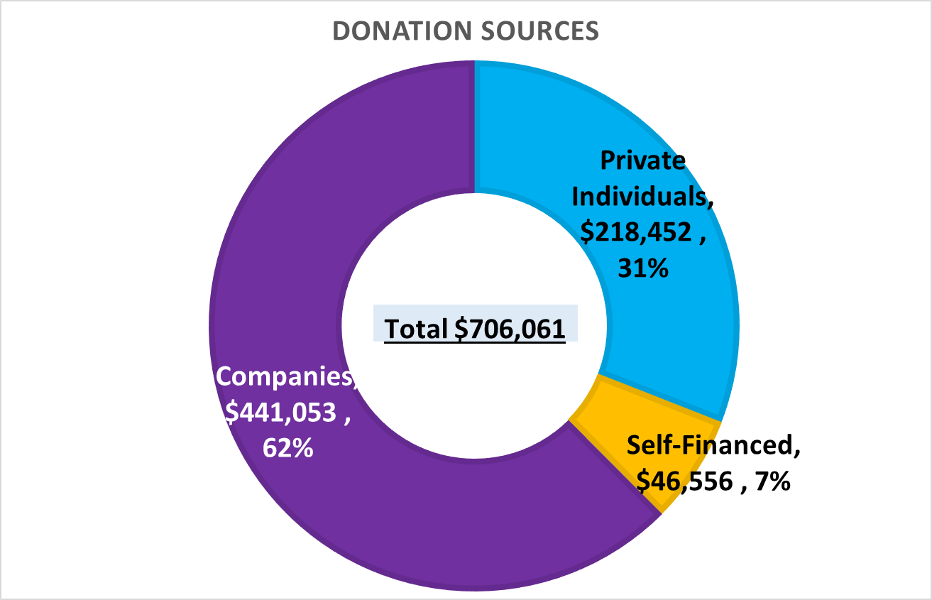Donations reported were indicated from three (3) sources: private individuals, self-financed and company donations.

Donations by private individuals accounted for 31% ($218,452) of total donations, while self-financed donations accounted for 7% ($46,556) and company donations 62% ($441,053).

The breakout for the Political Parties and Independent Candidates with each donation sources are outlined in the table and graphs below.

|  |  |  |  |  |  |  |  |
| --- | --- | --- | --- | --- | --- | --- | --- |
| **Entity** | **Private Individuals** | | **Self-Financed** | | **Companies** | | **Total** |
| **$** | **%** | **$** | **%** | **$** | **%** |
| Political Parties | 161,068 | 28% | 0 | 0% | 415,640 | 72% | 576,708 |
| Independent Candidates | 57,384 | 44% | 46,556 | 36% | 25,413 | 20% | 129,353 |
| **Total** | **218,452** | **31%** | **46,556** | **7%** | **441,053** | **62%** | **706,061** |

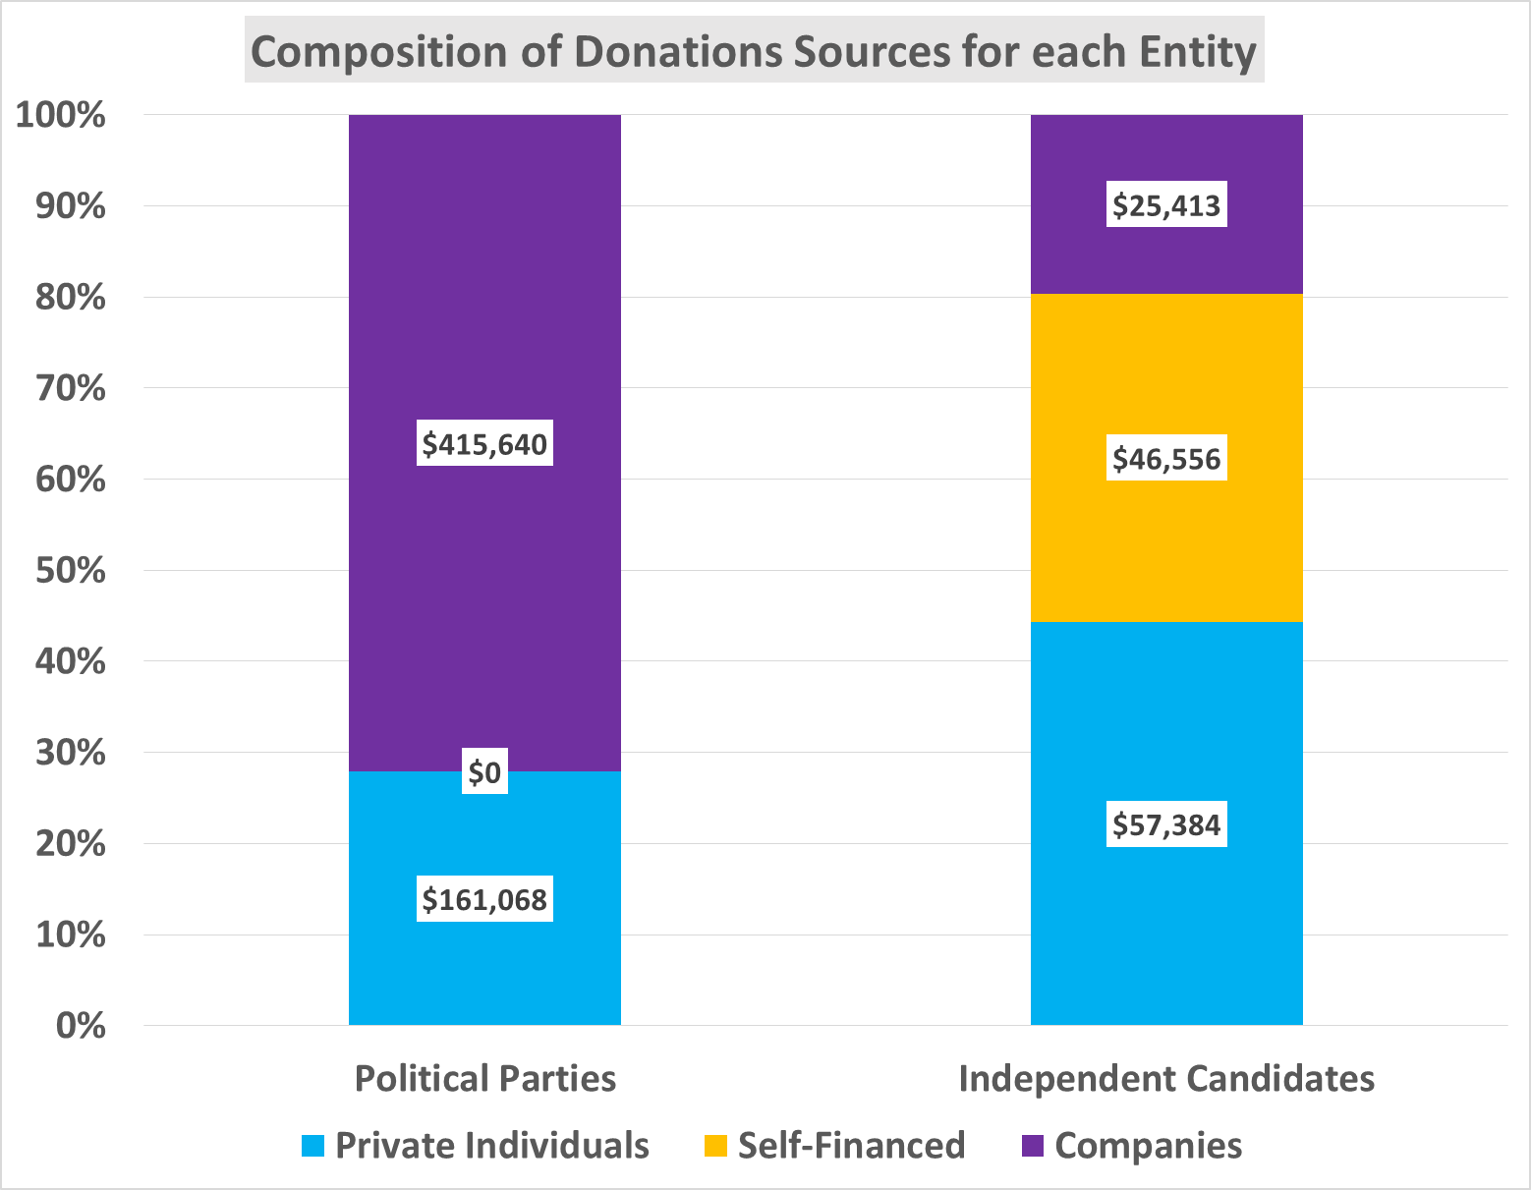

**Composition of Donation Sources**

The composition for each donation source is outlined below.

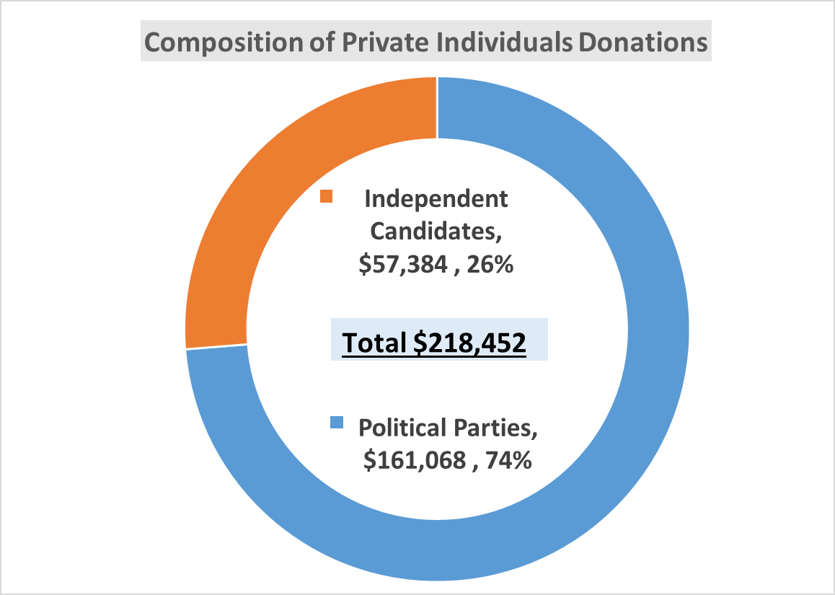**Private Individuals Donations**

Political Parties accounted for 74% of the donations by private individual while Independent Candidates accounted for 26%.

|  |  |  |
| --- | --- | --- |
| **Entity** | **Private Individuals** | |
| **$** | **%** |
| Political Parties | 161,068 | 74% |
| Independent Candidates | 57,384 | 26% |
| **Total** | **218,452** | **100%** |

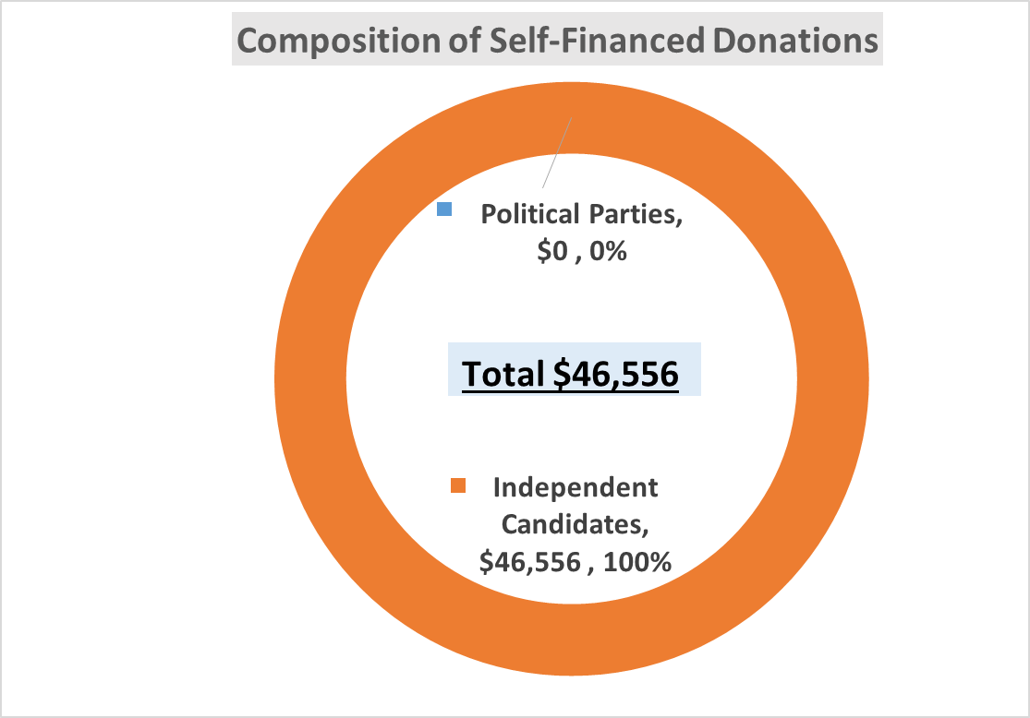**Self-Financed Donations**

Independent Candidates accounted for 100% of the self-financed donations. Political Parties did not report any self-financed donations.

|  |  |  |
| --- | --- | --- |
| **Entity** | **Self-Financed** | |
| **$** | **%** |
| Political Parties | 0 | 0% |
| Independent Candidates | 46,556 | 100% |
| **Total** | **46,556** | **100%** |

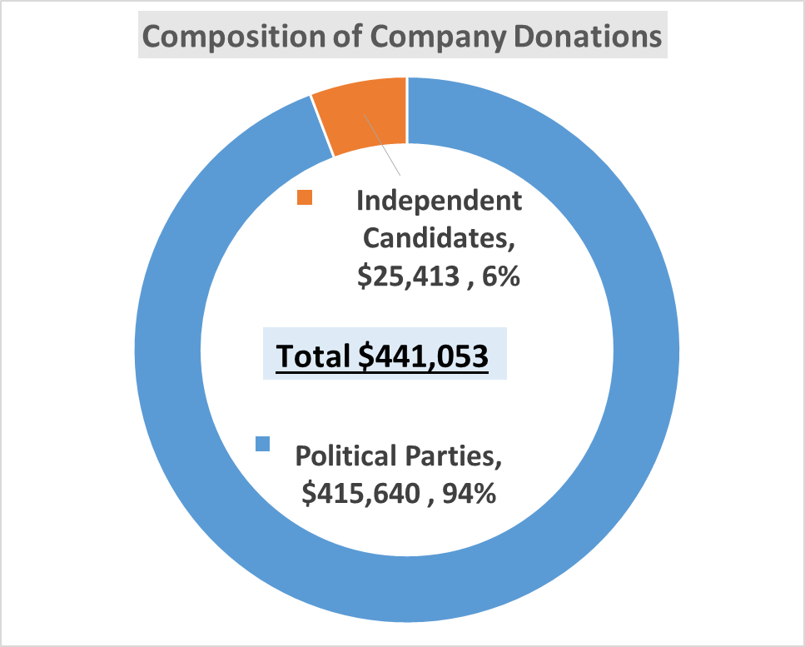**Company Donations**

Political Parties accounted for 94% of the company donations while Independent Candidates accounted 6%.

|  |  |  |
| --- | --- | --- |
| **Entity** | **Companies** | |
| **$** | **%** |
| Political Parties | 415,640 | 94% |
| Independent Candidates | 25,413 | 6% |
| **Total** | **441,053** | **100%** |

**DONATIONS REPORTED BY POLITICAL PARTIES**

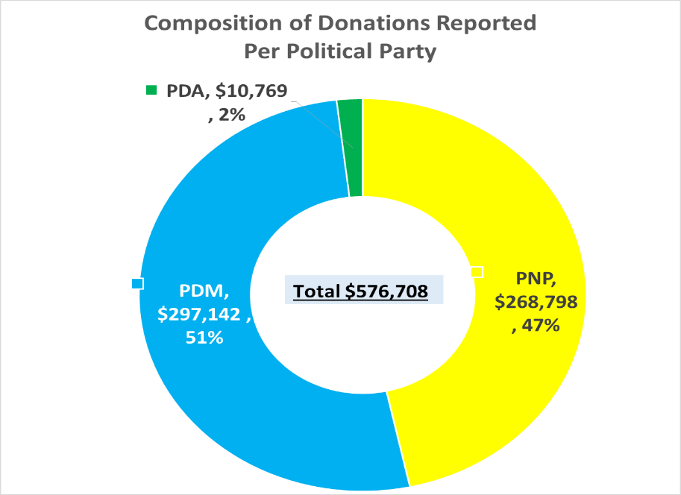**Donations Reported by Political Parties**

The total donations reported by the three (3) political parties amounted to **$576,708.**

The PDM accounted for 52% of the donations reported, the PNP accounted for 47% while the PDA accounted for 2%.

|  |  |  |
| --- | --- | --- |
| **Party** | **Donations $** | **(%)** |
| PNP | 268,798 | 47% |
| PDM | 297,142 | 52% |
| PDA | 10,769 | 2% |
| **Total** | **576,708** | **100%** |

**Donations Reported versus Legal Campaign Expenditure Limit for Political Parties**

The overall reported donations of $576,708 amounted to 32% of the $1.8M permitted for the three (3) parties combined.

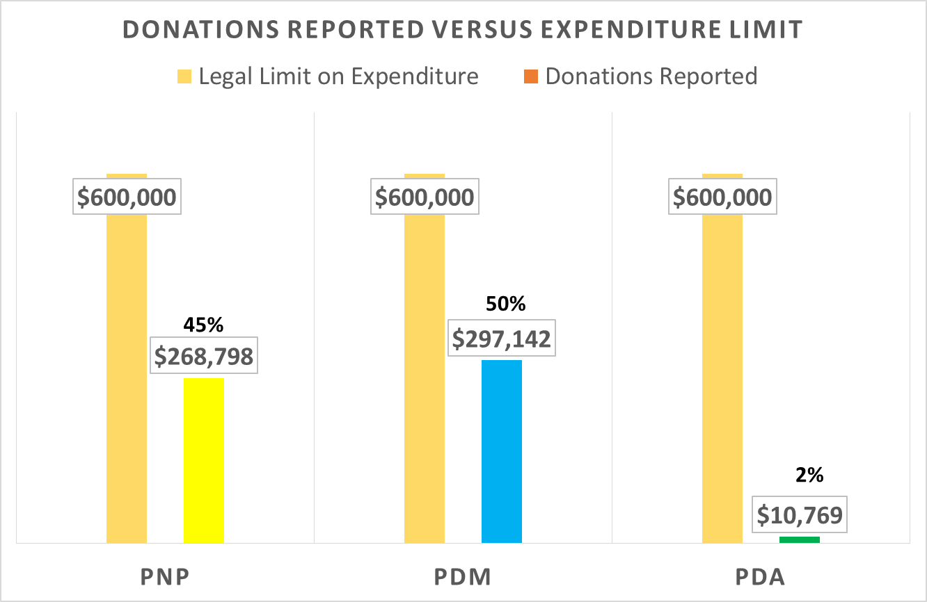Donations reported by the three (3) Political Parties were each within the legal expenditure limit of $600,000 per each party.

The PNP reported receiving 45% of the $600,000 expenditure limit; the PDM reported 50% while the PDA reported receiving 2%. See table and chart below.

|  |  |  |  |
| --- | --- | --- | --- |
| **Party** | **Legal Limit on Expenditure** | **Donations Reported** | **Donation Reported as a % of Expenditure Limit** |
| PNP | 600,000 | 268,798 | 45% |
| PDM | 600,000 | 297,142 | 50% |
| PDA | 600,000 | 10,769 | 2% |
| **Total** | **1,800,000** | **576,708** | **32%** |

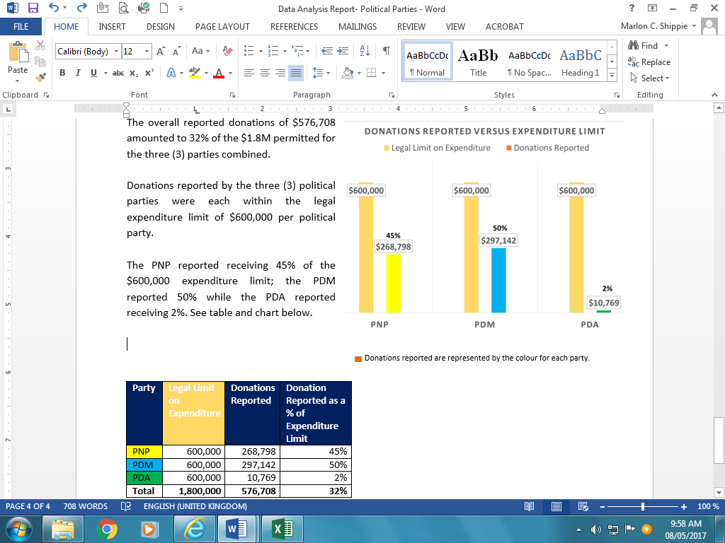

**Composition of Donations: Cash vs Non-Cash**

Of the total donations reported, cash donations represented 91% whereas 9% was reported as non-cash donations. Non-cash donations comprised primarily of - use of services/equipment, donation of actual items, discounts by suppliers or payment for items on behalf of the Parties.

The PNP reported 100% of their donations were in cash while the PDM and PDA both reported 83% of their donations as cash. See table and chart below for the composition of donations by Political Parties.

|  |  |  |  |  |  |  |
| --- | --- | --- | --- | --- | --- | --- |
| **Party** | **Cash** | | **Non-Cash** | | **Total** | **Total (%)** |
| $ | % | $ | % |
| PNP | 268,718 | 100% | 80 | 0% | 268,798 | 47% |
| PDM | 245,800 | 83% | 51,342 | 17% | 297,142 | 52% |
| PDA | 8,929 | 83% | 1,840 | 17% | 10,769 | 2% |
| **Total** | **523,447** | **91%** | **53,262** | **9%** | **576,708** | **100%** |

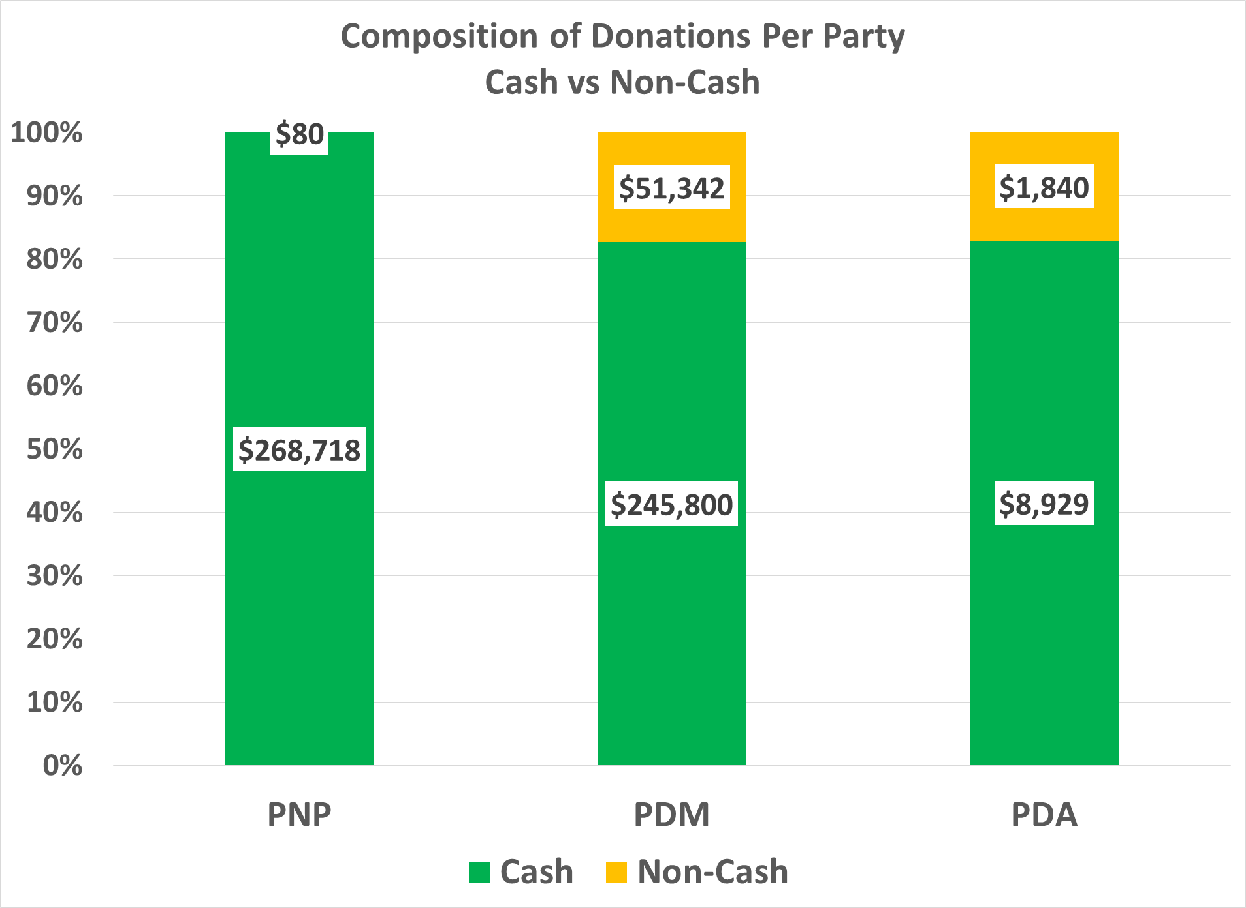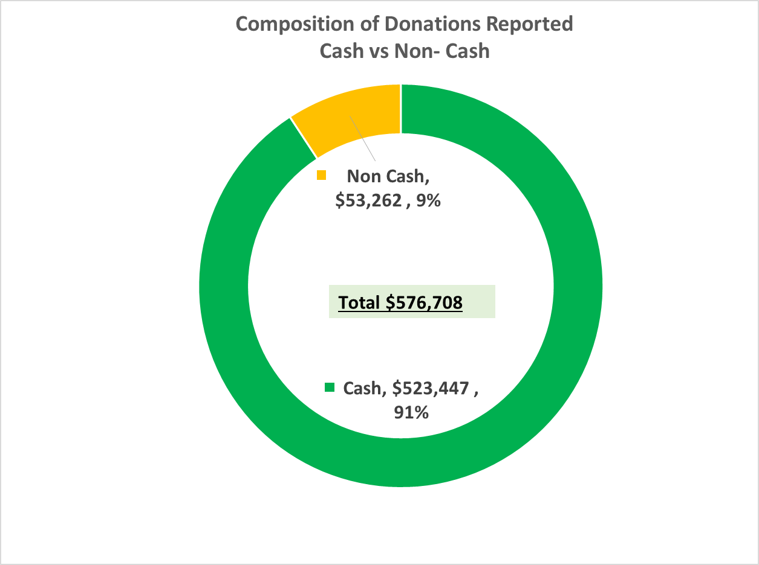

**Composition of Cash Donations: Paid directly to Vendors vs Paid to Political Parties**

It may be important to highlight that a portion of the cash donations reported were indicated to have been “paid directly to vendors” by the donors.

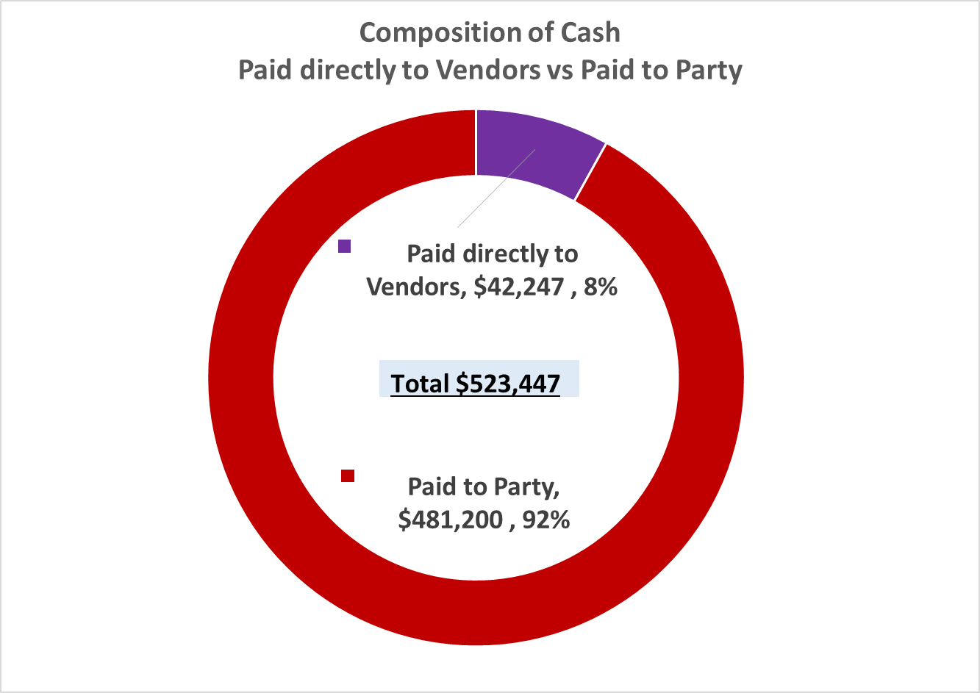Of the $523,447 reported as cash donations, 8% ($42,247) was reported as “paid directly to vendors” while 92% ($481,200) was reported as paid to the party.

The majority of the cash reported as “paid directly to vendors” was made by the PNP which amounted to $33,818. The PDA reported $8,429. The PDM did not report any cash donations as being “paid directly to vendors”.

The PDM reported 100% of their cash donations as paid to the party. The PNP reported 87% while the PDA reported 6% of cash donations as paid to the party.

See charts and table for composition of cash donations.

|  |  |  |  |  |  |
| --- | --- | --- | --- | --- | --- |
| **Party** | **Paid directly to Vendors** | | **Paid to Party** | | **Total**  **$** |
| **$** | **%** | **$** | **%** |
| PNP | 33,818 | 13% | 234,900 | 87% | 268,718 |
| PDM | 0 | 0% | 245,800 | 100% | 245,800 |
| PDA | 8,429 | 94% | 500 | 6% | 8,929 |
| **Total** | **42,247** | **8%** | **481,200** | **92%** | **523,447** |

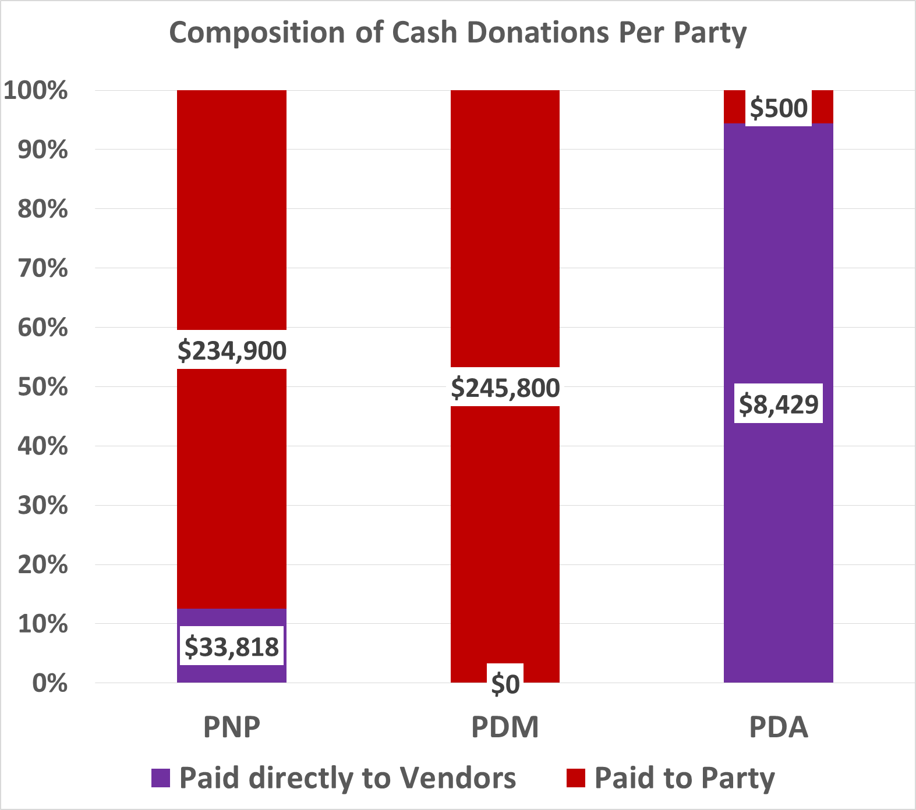

**Donation Sources: Companies vs Private Individuals**

Donations reported by the parties were indicated from two (2) sources: private individuals and company donations.

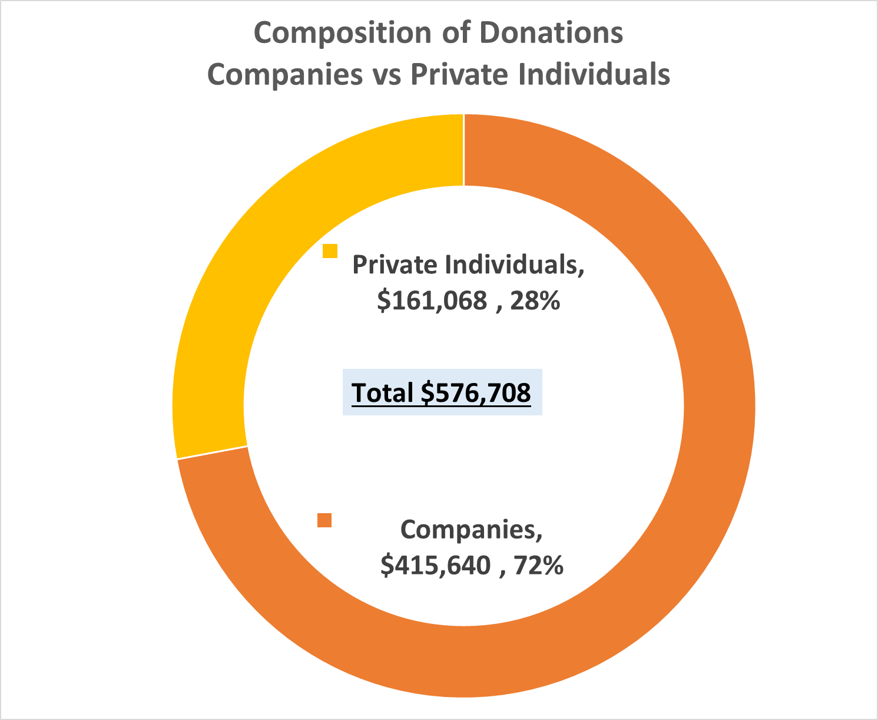72% ($415,640) of the party donations were reported from companies while 28% ($161,068) were accounted for by private individuals. See table and graph below.

|  |  |  |  |
| --- | --- | --- | --- |
| **Party** | **Donations** | | **Total** |
| **Companies** | **Private Individuals** |
| PNP | 191,000 | 77,798 | 268,798 |
| PDM | 222,800 | 74,342 | 297,142 |
| PDA | 1,840 | 8,929 | 10,769 |
| **Total** | **415,640** | **161,068** | **576,708** |
| **%** | **72%** | **28%** | **100%** |

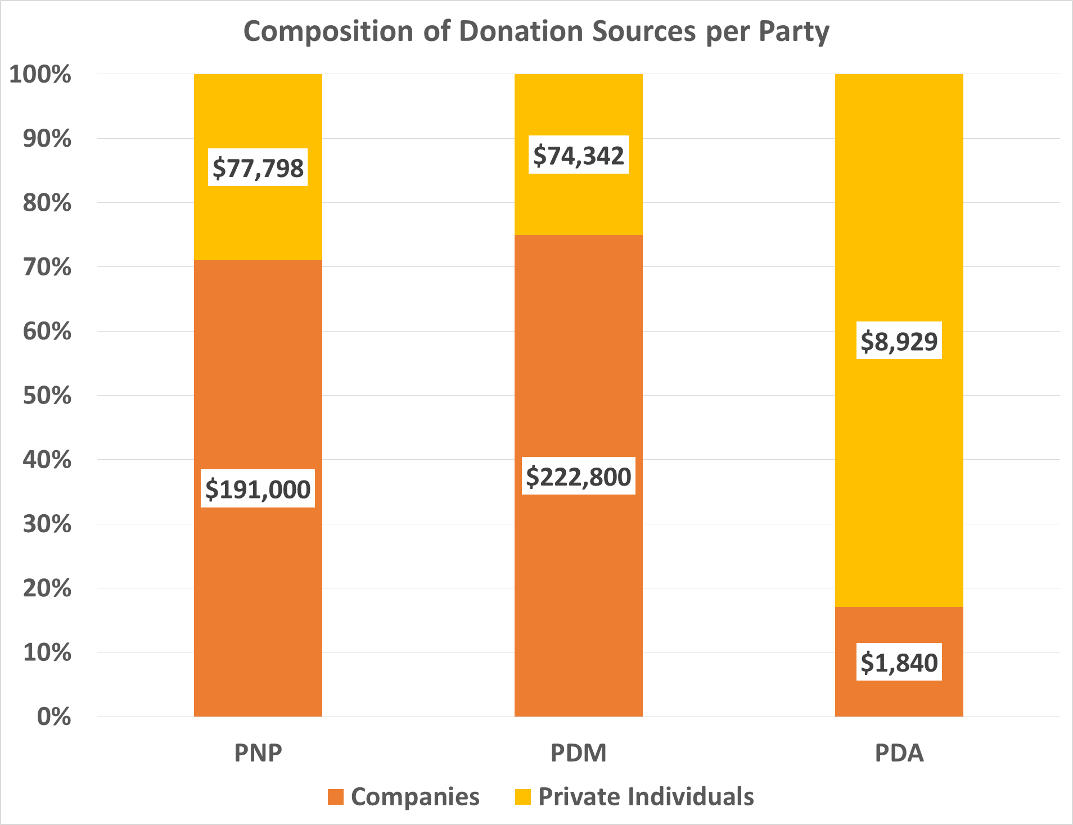The PDM reported 75% of their donations were from companies while the PNP reported 71% and the PDA 17%.

The percentages for each party for company and private individual donations are depicted in the table and graph below.

|  |  |  |  |  |  |
| --- | --- | --- | --- | --- | --- |
| **Party** | **Companies** | | **Private Individuals** | | **Total** |
| **$** | **%** | **$** | **%** |
| PNP | 191,000 | 71% | 77,798 | 29% | 268,798 |
| PDM | 222,800 | 75% | 74,342 | 25% | 297,142 |
| PDA | 1,840 | 17% | 8,929 | 83% | 10,769 |
| **Total** | **415,640** | **72%** | **161,068** | **28%** | **576,708** |

**Composition of Donation Sources**

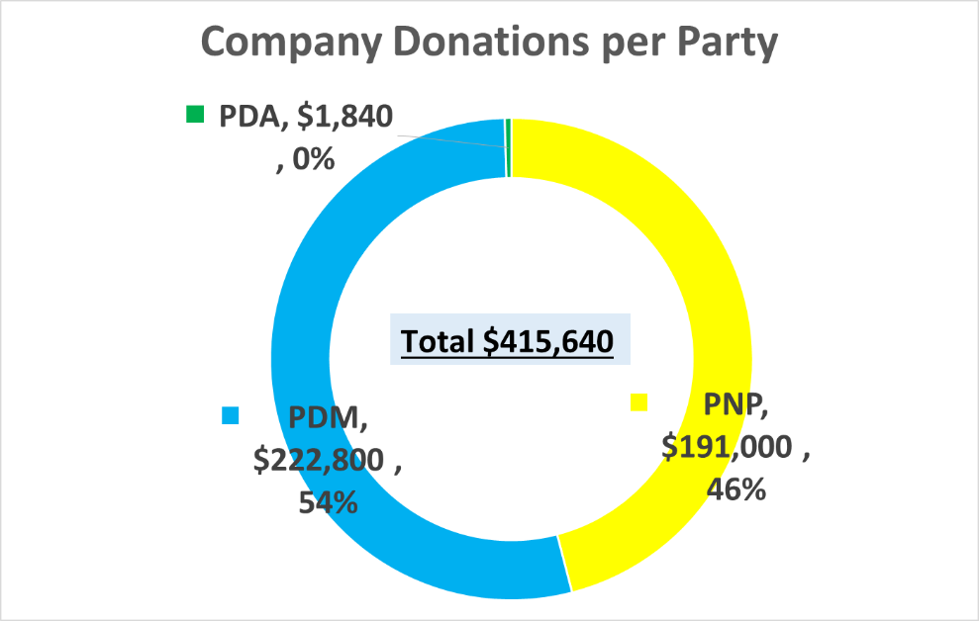**Composition of Company Donations**

The PDM accounted for 54% of the company donations while the PNP accounted for 46%. The PDA’s company donations were immaterial. See table and graph below.

|  |  |  |
| --- | --- | --- |
| **Party** | **Companies** | **%** |
| PNP | 191,000 | 46% |
| PDM | 222,800 | 54% |
| PDA | 1,840 | 0% |
| **Total** | **415,640** | **100%** |

**Composition of Private Individual Donations**

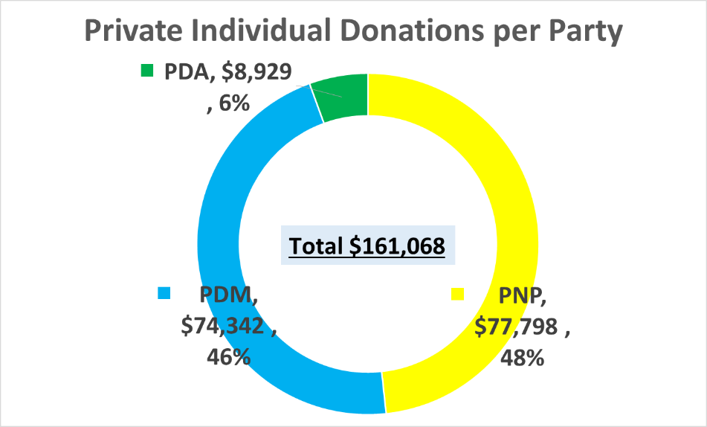

The PNP accounted for 48% of the private individual donations while the PDM accounted for 46%. The PDA accounted for 6%. See table and graph below.

|  |  |  |
| --- | --- | --- |
| **Party** | **Private Individuals** | **%** |
| PNP | 77,798 | 48% |
| PDM | 74,342 | 46% |
| PDA | 8,929 | 6% |
| **Total** | **161,068** | **100%** |

**DONATIONS REPORTED BY INDEPENDENT CANDIDATES**

**Donations Reported by Independent Candidates**

Total donations reported by the ten (10) Independent Candidates amounted to **$129,353**.

Three (3) candidates accounted for 75% of the total donations reported by Independent Candidates.

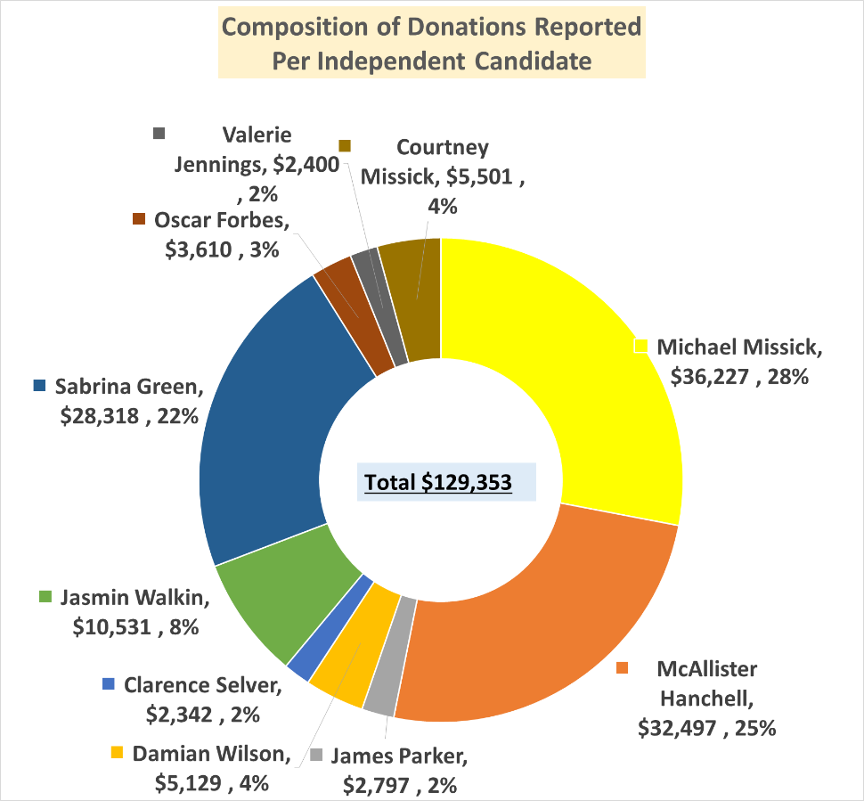Michael Missick accounted for 28% of the donations reported, McAllister Hanchell had 25% and Sabrina Green had 22% of the total donations reported.

The remaining seven (7) candidates individually accounted for less than 9% of the donations reported. See table and chart below.

|  |  |  |
| --- | --- | --- |
| **Candidate** | **Donations $** | **%** |
| Michael Missick | 36,227 | 28% |
| McAllister Hanchell | 32,497 | 25% |
| James Parker | 2,797 | 2% |
| Damian Wilson | 5,129 | 4% |
| Clarence Selver | 2,342 | 2% |
| Jasmin Walkin | 10,531 | 8% |
| Sabrina Green | 28,318 | 22% |
| Oscar Forbes | 3,610 | 3% |
| Valerie Jennings | 2,400 | 2% |
| Courtney Missick | 5,501 | 4% |
| **Total** | **129,353** | **100%** |

**Donations Reported versus Legal Expenditure Limit for Independent Candidates**

**All Island Constituency**

The overall reported donations for the seven (7) All Island Independent Candidates amounted to $91,659. This represents 13% of the total combined expenditure limit of $700,000 for the seven (7) candidates.

Michael Missick and Sabrina Green reported the highest donations at $36,227 and $28,318 respectively. Their individual donations were 36% and 28% respectively of the expenditure limit.

Oscar Forbes and Clarence Selver reported the lowest donation amounts and were 4% and 2% respectively of the expenditure limit.

The graph below outlines the donations for each All Island Independent Candidate compared to the individual expenditure legal limit of $100,000.

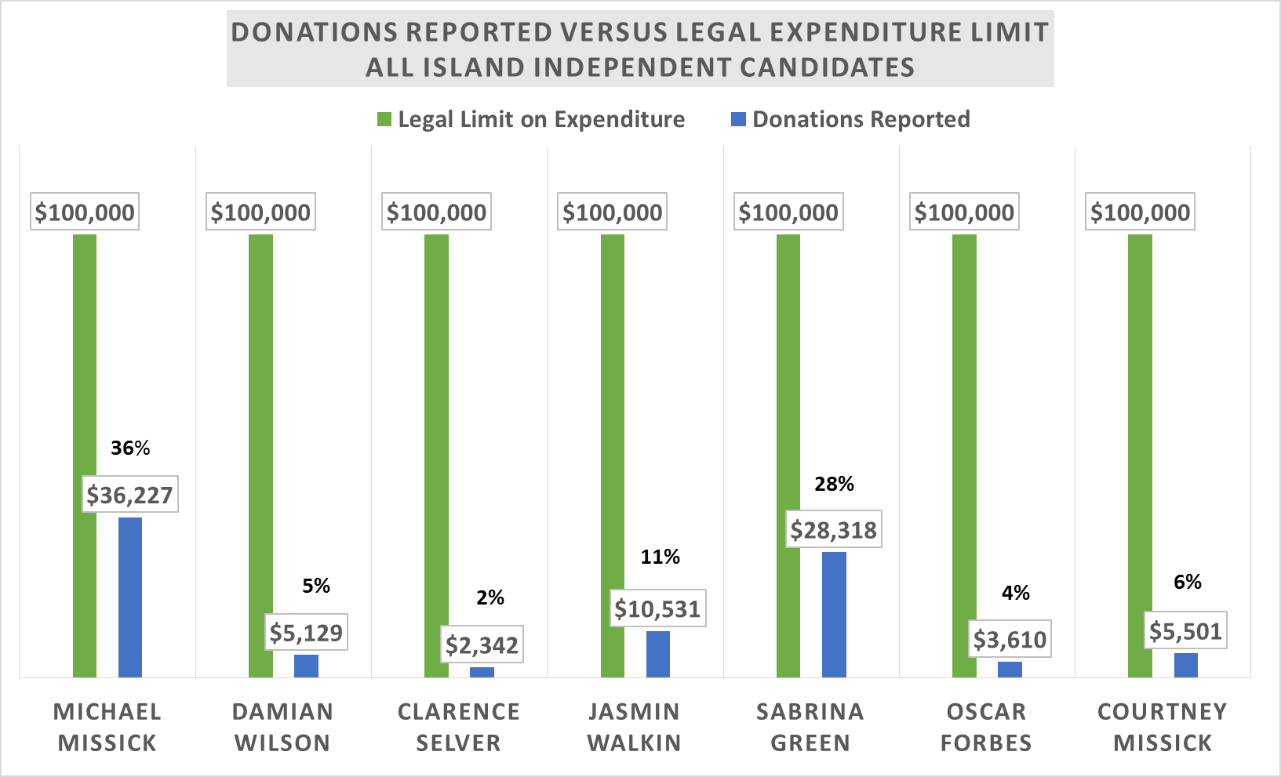

**Individual/District Constituency**

The overall reported donations for the three (3) Independent Candidates amounted to $37,695. This represents 42% of the total combined expenditure limit of $90,000 for the three (3) candidates.

**McAllister Hanchell reported the highest donations of $32,497 which is 108% of the expenditure limit. This candidate would be expected to have surplus donations upon reaching his legal campaign expenditure limit of $30,000.** The other two (2) candidates James Parker and Valerie Jennings each reported donations which were 9% and 8% respectively of the expenditure limit.

The graph below outlines the donations for each of the three (3) Independent Candidate compared to the individual expenditure legal limit of $30,000.

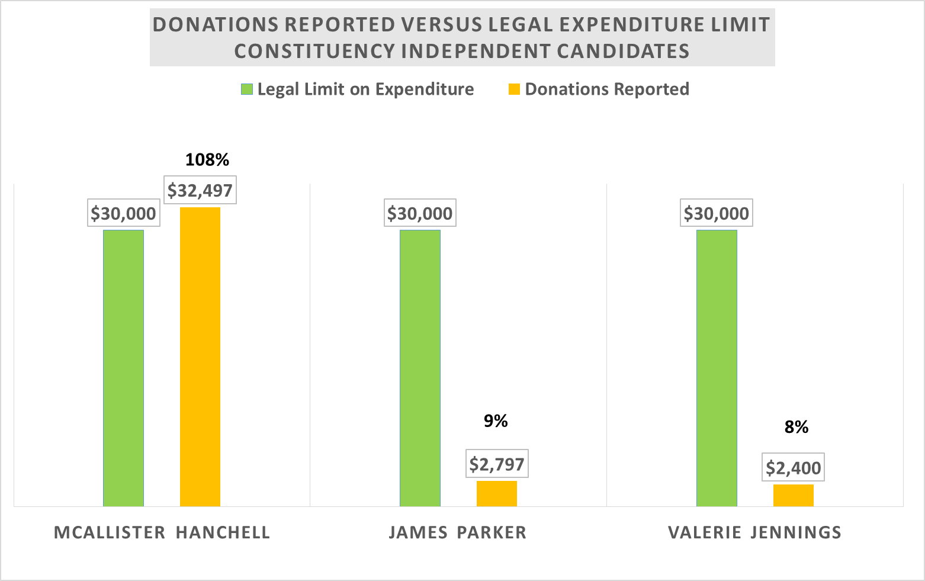

**Composition of Donations: Cash vs Non-Cash**

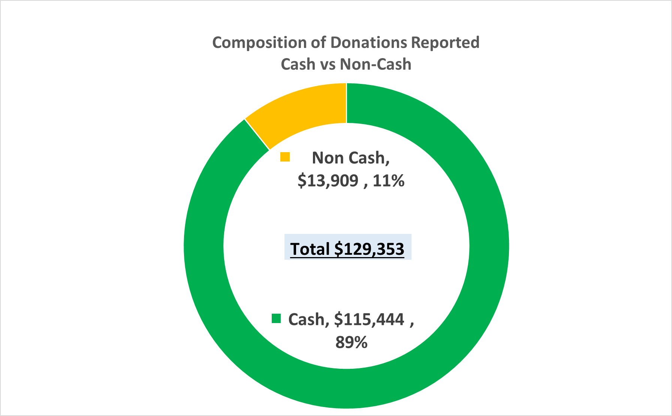Of the total donations reported, cash donations represented 89% while non-cash donations accounted for 11%. Non-cash donations comprised primarily of - discounts by suppliers, use of services or equipment, donation of actual items, or payment for items on behalf of the candidates.

|  |  |  |  |  |  |
| --- | --- | --- | --- | --- | --- |
| **Candidate** | **Cash** | | **Non-Cash** | | **Total** |
| **$** | **%** | **$** | **%** |
| Michael Missick | 31,000 | 86% | 5,227 | 14% | 36,227 |
| McAllister Hanchell | 26,564 | 82% | 5,934 | 18% | 32,497 |
| James Parker | 2,612 | 93% | 185 | 7% | 2,797 |
| Damian Wilson | 4,529 | 88% | 600 | 12% | 5,129 |
| Clarence Selver | 1,550 | 66% | 792 | 34% | 2,342 |
| Jasmin Walkin | 9,550 | 91% | 981 | 9% | 10,531 |
| Sabrina Green | 28,318 | 100% | 0 | 0% | 28,318 |
| Oscar Forbes | 3,520 | 98% | 90 | 2% | 3,610 |
| Valerie Jennings | 2,400 | 100% | 0 | 0% | 2,400 |
| Courtney Missick | 5,401 | 98% | 100 | 2% | 5,501 |
| **Total** | **115,444** | **89%** | **13,909** | **11%** | **129,353** |

Two (2) candidates reported 100% cash donations - Sabrina Green and Valerie Jennings. The other eight (8) candidates reported a mixture of cash and non-cash donations. The graph below highlights the cash to non-cash percentage for each candidate.

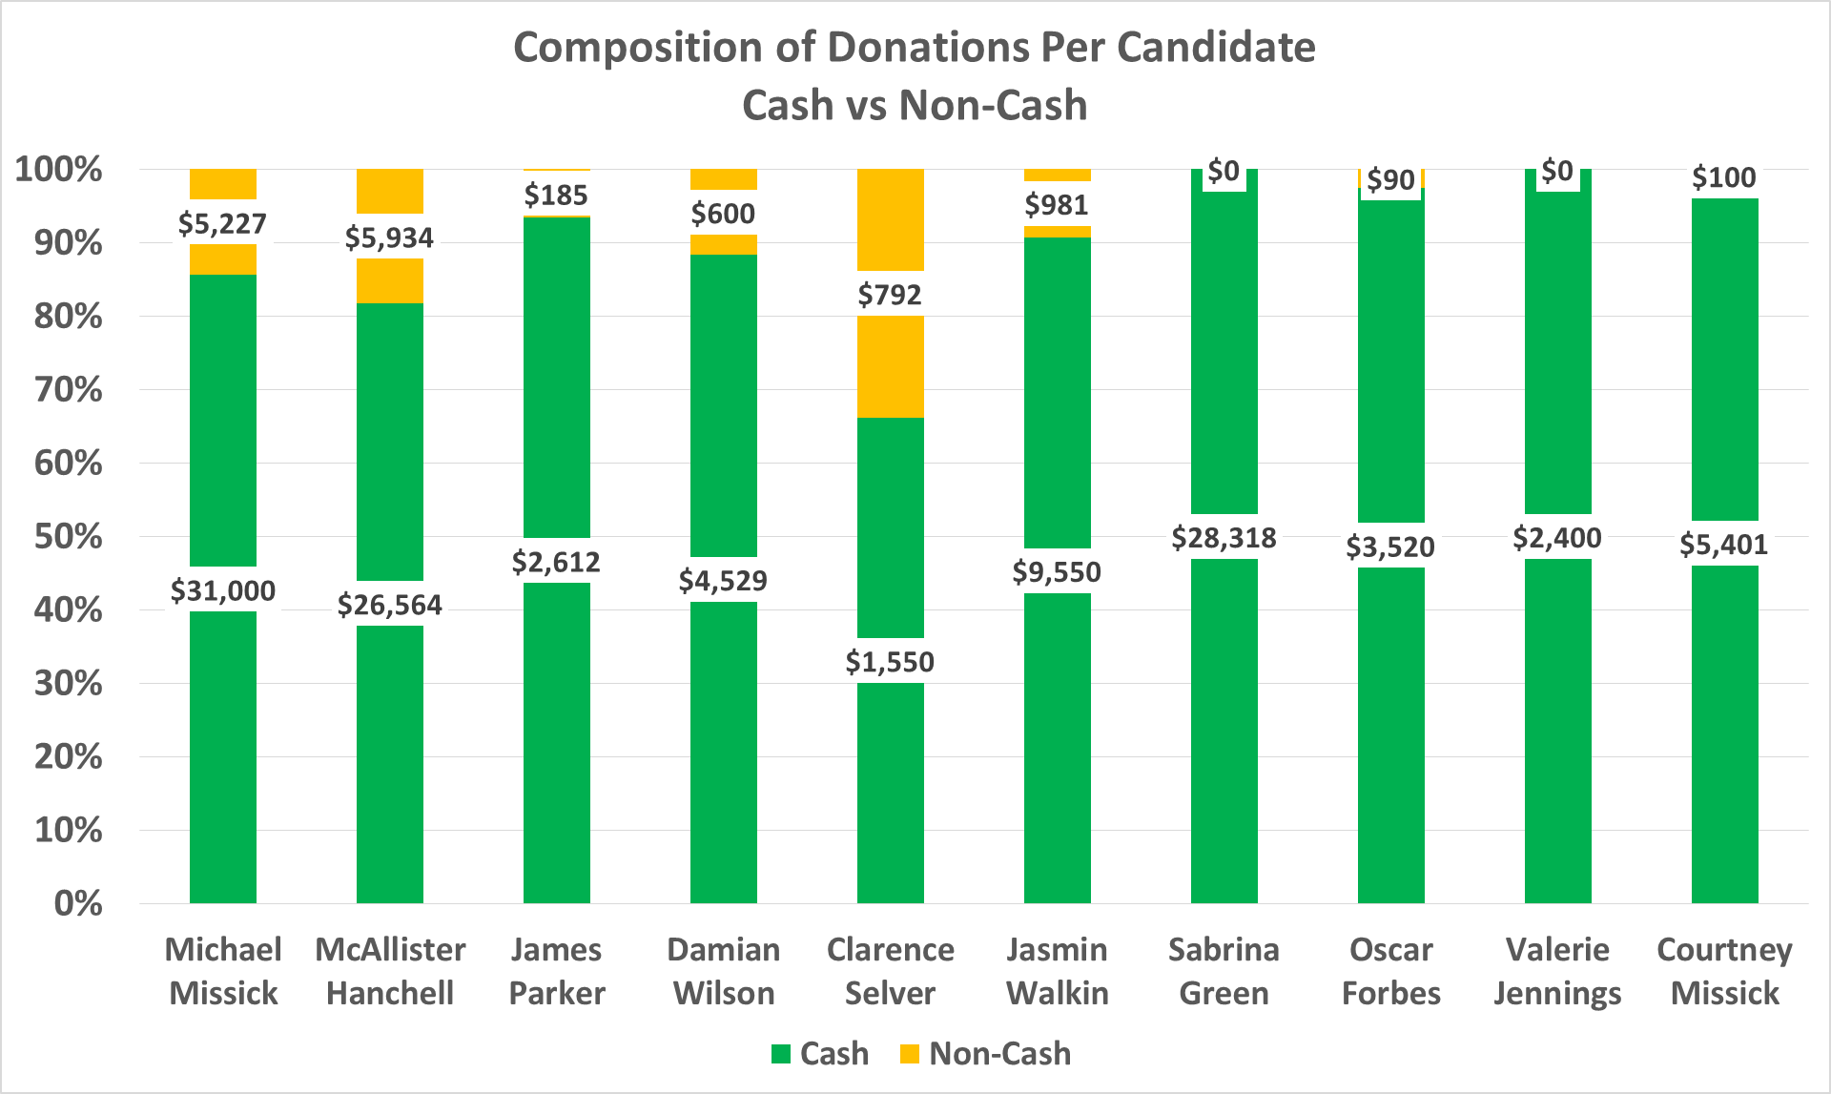

**Composition of Cash Donations: Self-Financed vs Financed by Donors**

A portion of the cash donations reported by the candidates were indicated to have been “self-financed”.

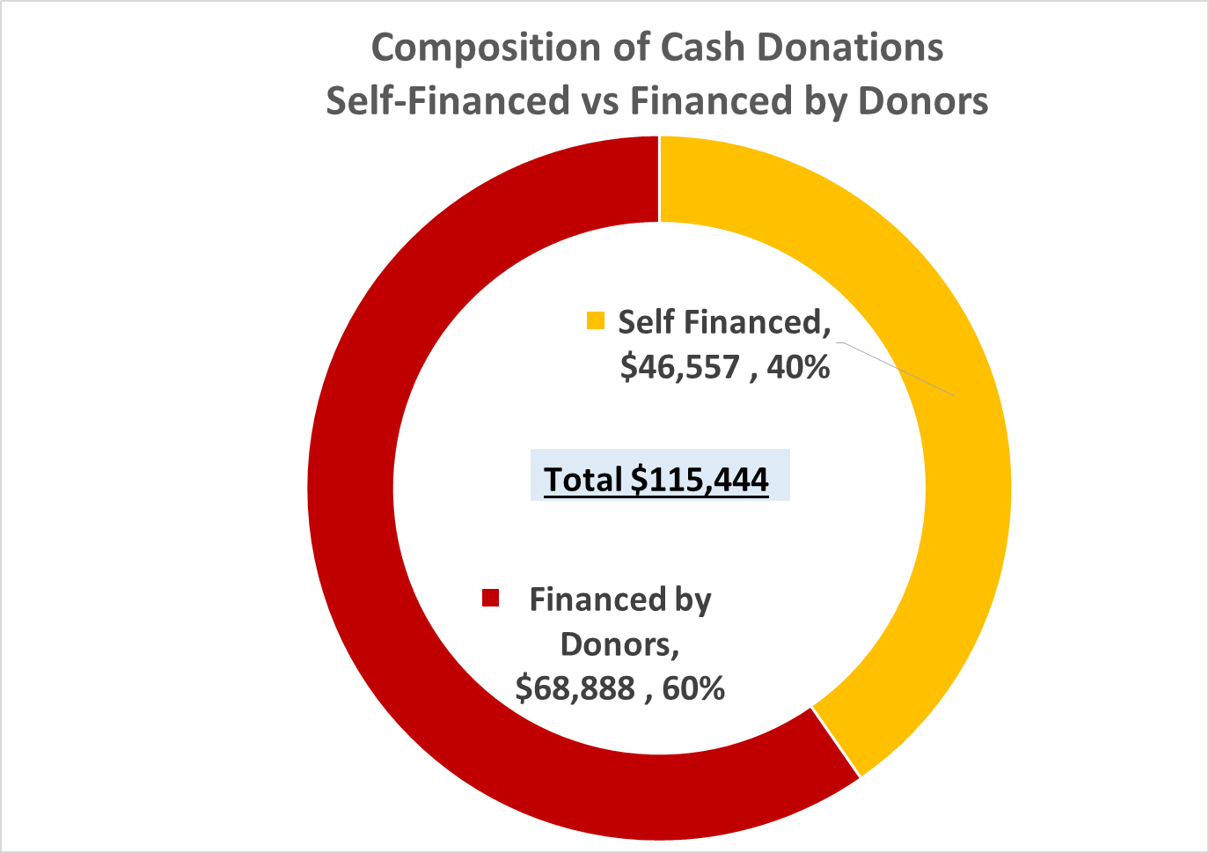Of the $115,444 reported as cash donations, 40% ($46,557) was reported as “self-financed” while the remaining 60% ($68,888) was financed by donors.

Three (3) candidates reported 100% self-financing with a combined total of $34,577. These candidates were McAllister Hanchell, James Parker and Courtney Missick.

Three (3) candidates reported 100% donor funding with a combined total of $42,100. These candidates were Michael Missick, Clarence Selver and Jasmin Walkin.

The remaining four (4) candidates reported a mixture of “self-financed” and donor funding. These candidates were Damian Wilson, Sabrina Green, Oscar Forbes and Valerie Jennings.

The table and graph below outlines the breakout of cash donations reported for each candidate.

|  |  |  |  |  |  |
| --- | --- | --- | --- | --- | --- |
| **Candidate** | **Self-Financed** | | **Financed by Donors** | | **Total Cash Donations** |
| **$** | **%** | **$** | **%** |
| Michael Missick | 0 | 0% | 31,000 | 100% | 31,000 |
| McAllister Hanchell | 26,564 | 100% | 0 | 0% | 26,564 |
| James Parker | 2,612 | 100% | 0 | 0% | 2,612 |
| Damian Wilson | 3,579 | 79% | 950 | 21% | 4,529 |
| Clarence Selver | 0 | 0% | 1,550 | 100% | 1,550 |
| Jasmin Walkin | 0 | 0% | 9,550 | 100% | 9,550 |
| Sabrina Green | 5,400 | 19% | 22,918 | 81% | 28,318 |
| Oscar Forbes | 2,500 | 71% | 1,020 | 29% | 3,520 |
| Valerie Jennings | 500 | 21% | 1,900 | 79% | 2,400 |
| Courtney Missick | 5,401 | 100% | 0 | 0% | 5,401 |
| **Total** | **46,557** | **40%** | **68,888** | **60%** | **115,444** |

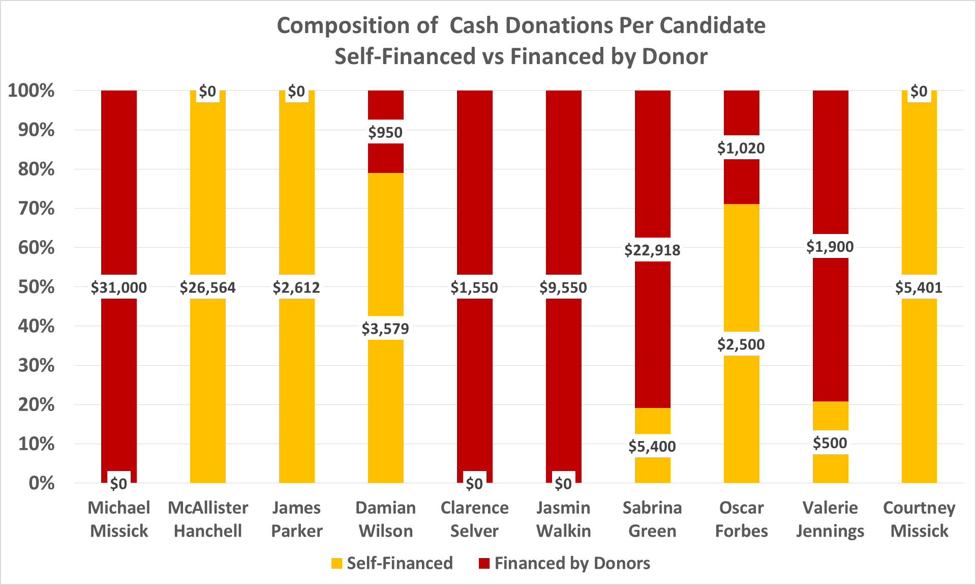

**Donation Sources: Private Individuals, Self-Financed and Companies**

Donations reported by Independent Candidates were indicated from three (3) sources: private individuals, self-financed and company donations.

Donations by private individuals accounted for 44% ($57,384) of total reported donations, while self-financed accounted for 36% ($46,557) and company donations 20% ($25,413). The composition of each donation source and the breakout for each candidate is outlined in the table and graphs below.

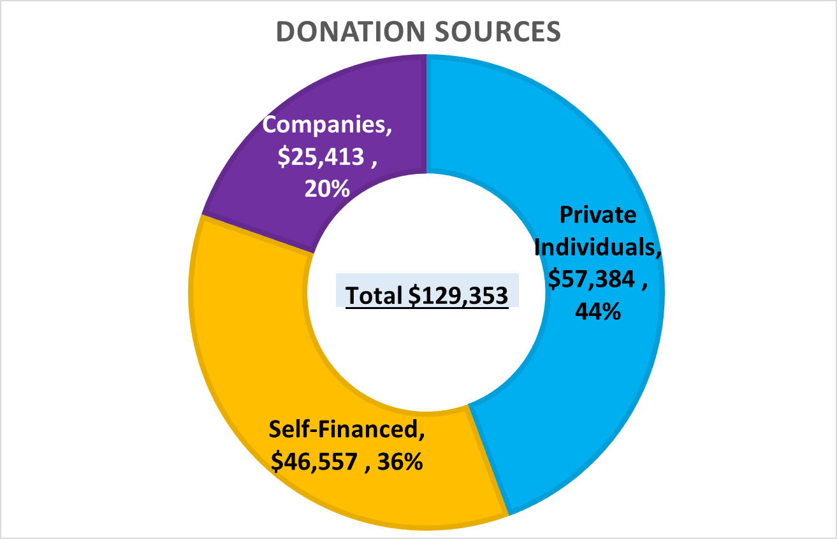



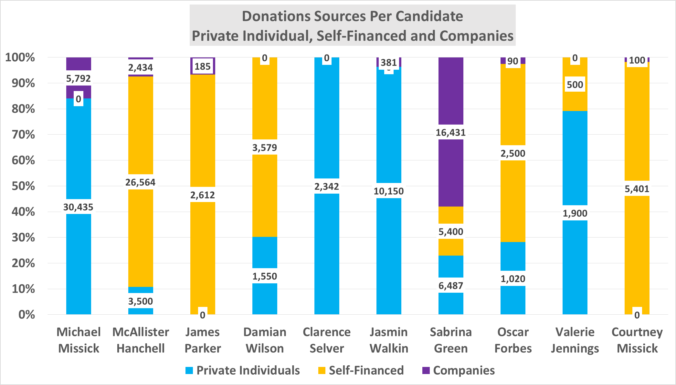

**Composition of Donation Sources**

**Private Individuals Donations**

Eight (8) of the ten (10) candidates reported donations from private individuals. James Parker and Courtney Missick did not report any donations from private individuals.

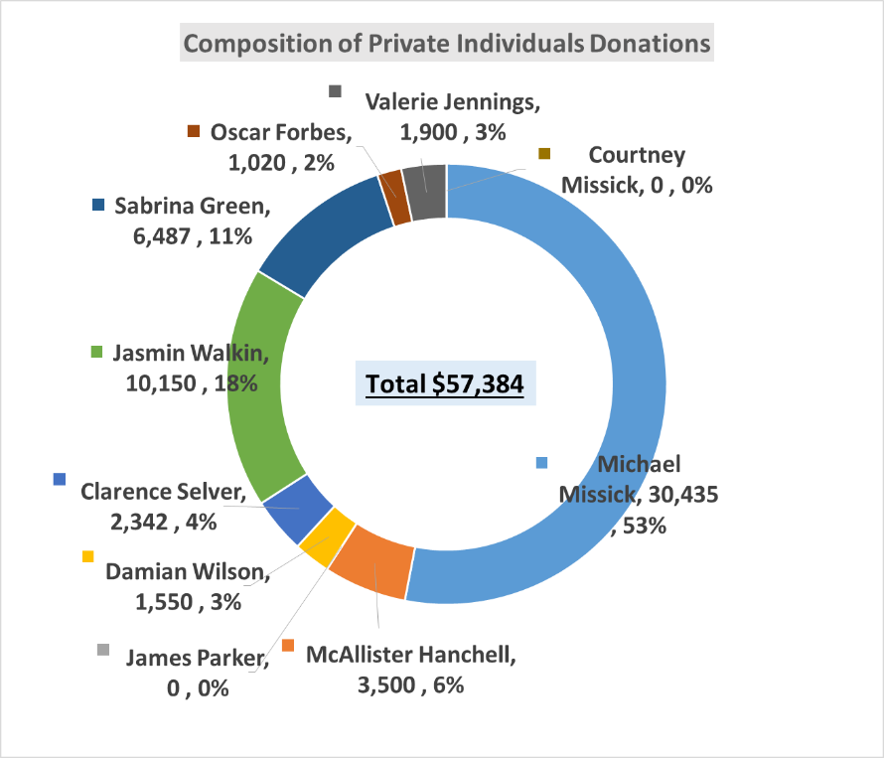Michael Missick accounted for 53% of the donations by private individual. Jasmin Walkin accounted for 18% and Sabrina Green had 11%. All other candidates each accounted for less than 10% of donations by private individuals.

|  |  |  |
| --- | --- | --- |
| **Candidate** | **Private Individuals** | |
| **$** | **%** |
| Michael Missick | 30,435 | 53% |
| McAllister Hanchell | 3,500 | 6% |
| James Parker | 0 | 0% |
| Damian Wilson | 1,550 | 3% |
| Clarence Selver | 2,342 | 4% |
| Jasmin Walkin | 10,150 | 18% |
| Sabrina Green | 6,487 | 11% |
| Oscar Forbes | 1,020 | 2% |
| Valerie Jennings | 1,900 | 3% |
| Courtney Missick | 0 | 0% |
| **Total** | **57,384** | **100%** |

**Self-Financed Donations**

Seven (7) of the ten (10) candidates reported self-financed donations. Michael Missick, Clarence Selver and Jasmin Walkin did not report any self-financed donations.

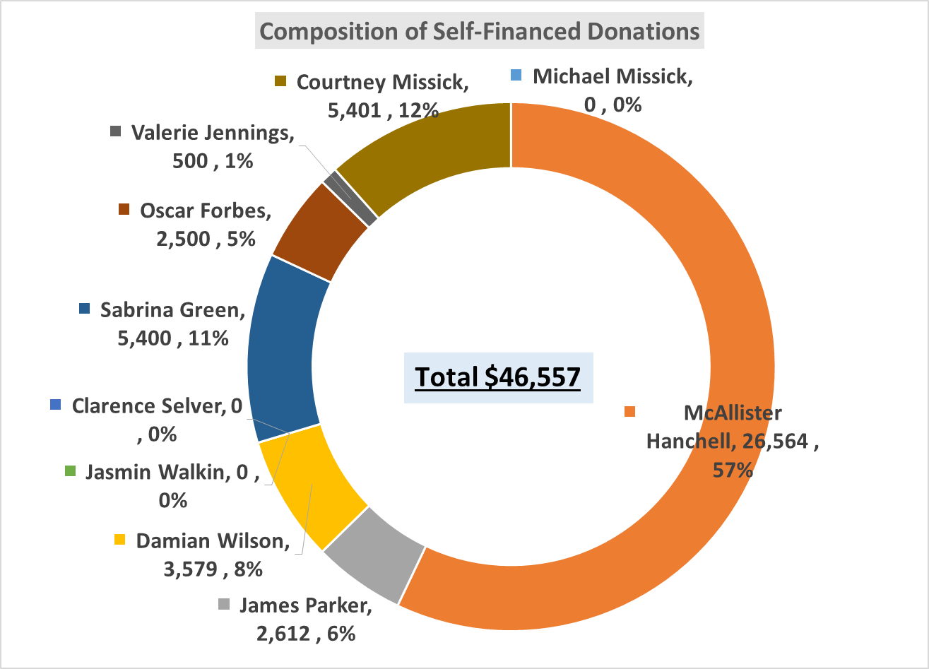McAllister Hanchell accounted for 57% of the self-financed donations. Sabrina Green and Courtney Missick each accounted for approximately 12%. All other candidates each accounted for less than 10% of self-financed donations.

|  |  |  |
| --- | --- | --- |
| **Candidate** | **Self-Financed** | |
| **$** | **%** |
| Michael Missick | 0 | 0% |
| McAllister Hanchell | 26,564 | 57% |
| James Parker | 2,612 | 6% |
| Damian Wilson | 3,579 | 8% |
| Clarence Selver | 0 | 0% |
| Jasmin Walkin | 0 | 0% |
| Sabrina Green | 5,400 | 12% |
| Oscar Forbes | 2,500 | 5% |
| Valerie Jennings | 500 | 1% |
| Courtney Missick | 5,401 | 12% |
| **Total** | **46,557** | **100%** |

**Company Donations**

Seven (7) of the ten (10) candidates had company donations. Damian Wilson, Clarence Selver and Valerie Jennings did not report any company donations.

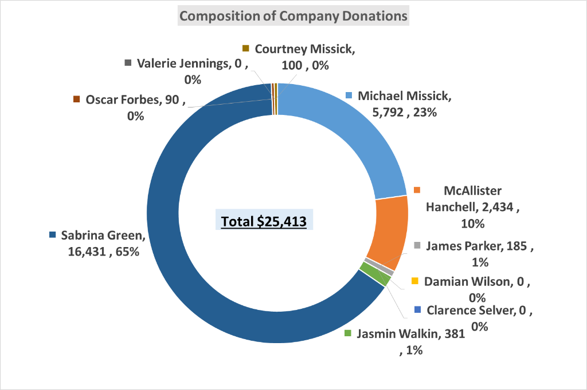Sabrina Green accounted for 65% of the company donations while Michael Missick had 23% and McAllister Hanchell had 10%. The remaining four (4) candidates accounted for a combined 2% of the total company donation.

|  |  |  |
| --- | --- | --- |
| **Candidate** | **Company**  **Donations** | |
| **$** | **%** |
| Michael Missick | 5,792 | 23% |
| McAllister Hanchell | 2,434 | 10% |
| James Parker | 185 | 1% |
| Damian Wilson | 0 | 0% |
| Clarence Selver | 0 | 0% |
| Jasmin Walkin | 381 | 1% |
| Sabrina Green | 16,431 | 65% |
| Oscar Forbes | 90 | 0% |
| Valerie Jennings | 0 | 0% |
| Courtney Missick | 100 | 0% |
| **Total** | **25,413** | **100%** |