**TOTAL EXPENDITURE REPORTED**

**Total Expenditure Reported**

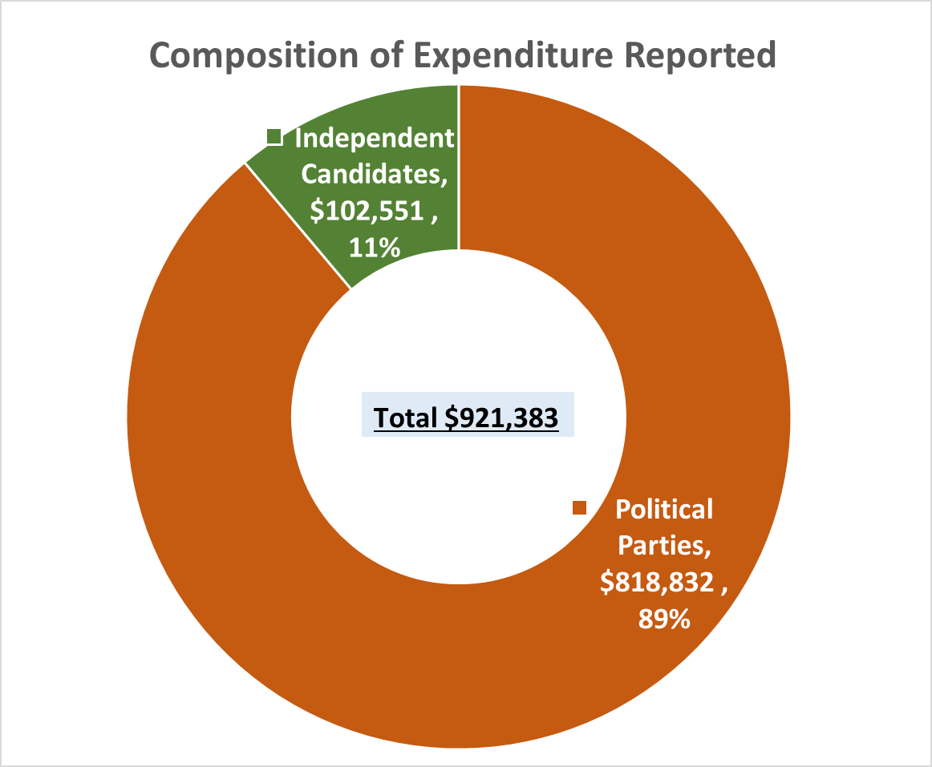

The total expenditure reported for the December 2016 election amounted to **$921,383.**

The Political Parties accounted for 89% of the expenditure reported whereas Independent Candidates accounted for 11%. See table and graph below.

|  |  |  |
| --- | --- | --- |
| **Entity** | **Expenditure** | **(%)** |
| Political Parties | 818,832 | 89% |
| Independent Candidates | 102,551 | 11% |
| **Total** | **921,383** | **100%** |

**Composition of Expenditure**

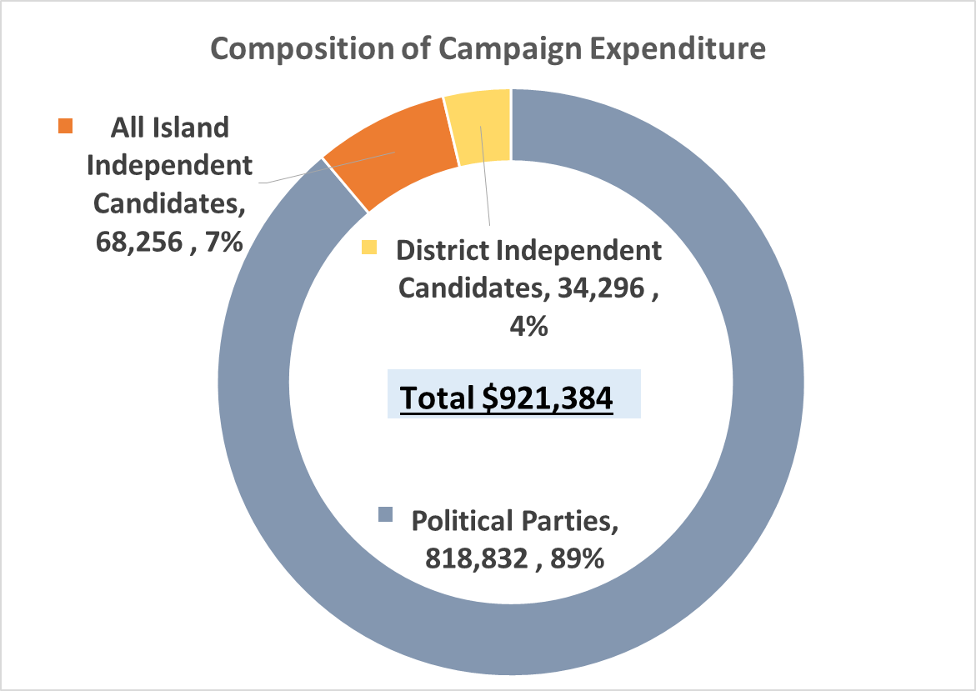Of the total expenditure reported, Political Parties expenditure represented 89% of the total, while expenditure by the All Island Independent Candidates accounted for 7% and District Independent Candidates for 4%. See table and chart below.

|  |  |  |
| --- | --- | --- |
| **Entity** | **Expenditure Reported** | **%** |
| Political Parties | 818,832 | 89% |
| All Island Independent Candidates | 68,256 | 7% |
| District Independent Candidates | 34,296 | 4% |
| **Total** | **921,384** | **100%** |

**Total Expenditure Reported versus Legal Expenditure Limit for Political Parties and Independent Candidates**

A comparison of the total expenditure reported by the Political Parties and the Independent Candidates against the legal expenditure limits was done. This comparison is described in the sections below.

The overall expenditure limit for the December 2016 elections is $2,590,000. The basis for determining the overall expenditure limit is as follows.

* The total legal limit for expenditure by each party is $600,000. The maximum combined expenditure permitted for the three (3) parties who contested the December 2016 election would amount to $1.8M. Detailed comparison for each Political Party is shown in the *Comparison of Political Parties Expenditure with legal expenditure limit* section below.
* Seven (7) independent candidates were nominated to run in the All Island constituency while three (3) ran in the Individual/District Constituencies. The legal limit for expenditure by each candidate at the All Island Constituency is $100,000 while the expenditure limit at the Individual Constituency is $30,000. The maximum combined expenditure permitted for the seven (7) candidates at the All Island Constituency amounts to $700,000 and $90,000 at the Individual Constituency level.

Detailed comparison for each Independent Candidate is shown in the *Comparison of All Island Independent Candidate Expenditure with legal expenditure limit* and *Comparison of District Independent Candidate Expenditure with legal expenditure limit* sections below.

**Comparison of Overall Expenditure with legal expenditure limit**

The overall reported expenditure of $921,383 amounts to 36% of the overall combined expenditure limit of $2.6M for the Political Parties and the Independent Candidates.

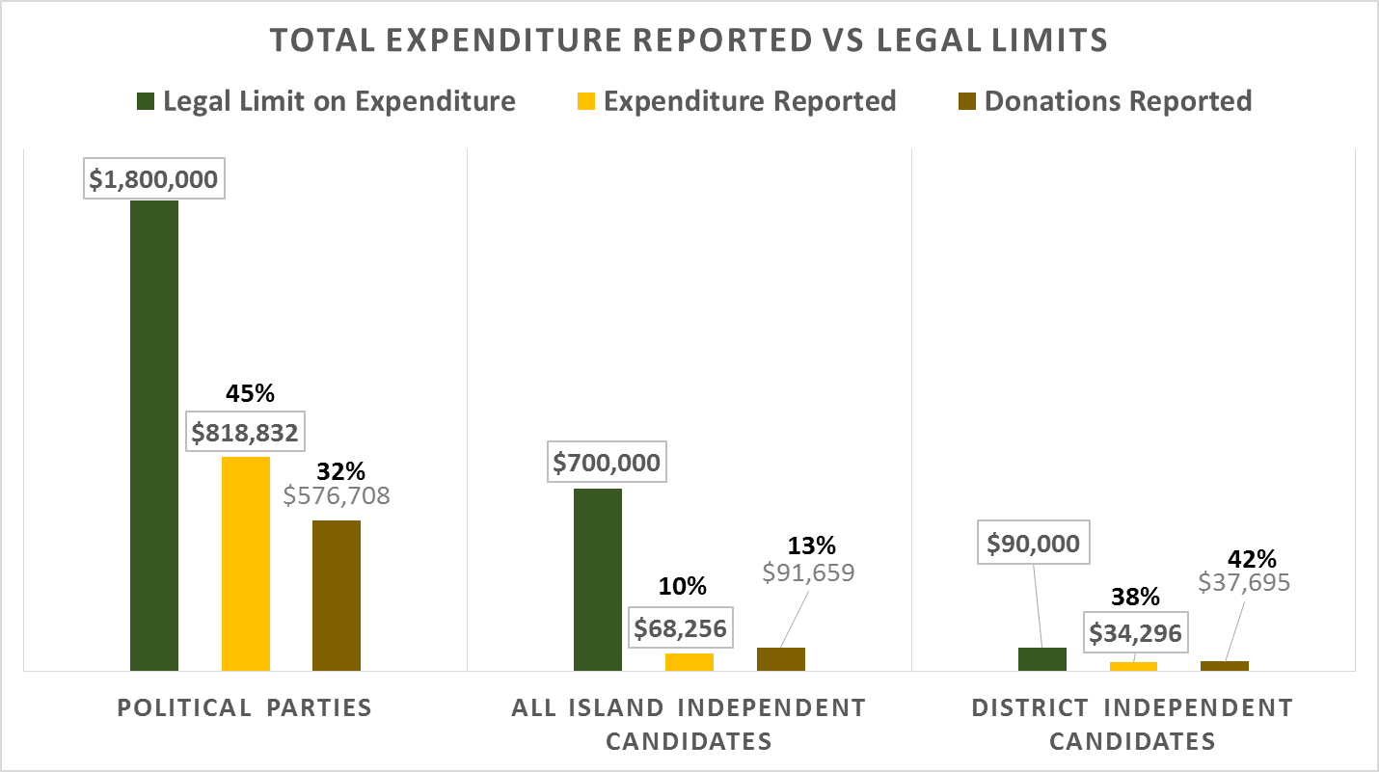Reported expenditure of $818,832 by the Political Parties were 45% of the combined legal expenditure limit of $1.8M.

The All Island Independent Candidates reported expenditure of $68, 256 was 10% of the combined legal expenditure limit of $700,000.

The District Independent Candidates reported expenditure of $34,296 was 38% of the combined legal expenditure limit of $90,000. See chart above and table below.

|  |  |  |  |  |  |
| --- | --- | --- | --- | --- | --- |
| **Entity** | **Legal Limit on Expenditure** | **Expenditure Reported** | **Donations Reported** | **Expenditure Reported as a % of Expenditure Limit** | **Donation Reported as a % of Expenditure Limit** |
| Political Parties | 1,800,000 | 818,832 | 576,708 | 45% | 32% |
| All Island Independent Candidates | 700,000 | 68,256 | 91,659 | 10% | 13% |
| District Independent Candidates | 90,000 | 34,296 | 37,695 | 38% | 42% |
| **Total** | **2,590,000** | **921,384** | **706,062** | **36%** | **27%** |

When the reported donations are added to the comparison, the results indicate the Political Parties donations represents 32% of the combined legal limit, the All Island Candidates 13% and the District Independent Candidates 42%. The Political Parties reported more expenditure during the election period (Oct-Dec) than the donations collected during the period while the Independent Candidates reported more donations collected during the election period than the expenditure incurred. See table below.

|  |  |  |  |  |  |
| --- | --- | --- | --- | --- | --- |
| **Entity** | **Legal Limit on Expenditure** | **Expenditure Reported** | **Donations Reported** | **Variation (Donation - Expenditure)** | **Variation % (shortfall in donations)** |
| Political Parties | 1,800,000 | 818,832 | 576,708 | (242,124) | -42% |
| All Island Independent Candidates | 700,000 | 68,256 | 91,659 | 23,403 | 26% |
| District Independent Candidates | 90,000 | 34,296 | 37,695 | 3,399 | 9% |
| **Total** | **2,590,000** | **921,384** | **706,062** | **(215,322)** | **-30%** |

An analysis of these variations are outlined in the sections below.

**Comparison of Political Parties Expenditure with legal expenditure limit**

Reported expenditure of $818,832 by the Political Parties were 45% of the combined legal expenditure limit of $1.8M.

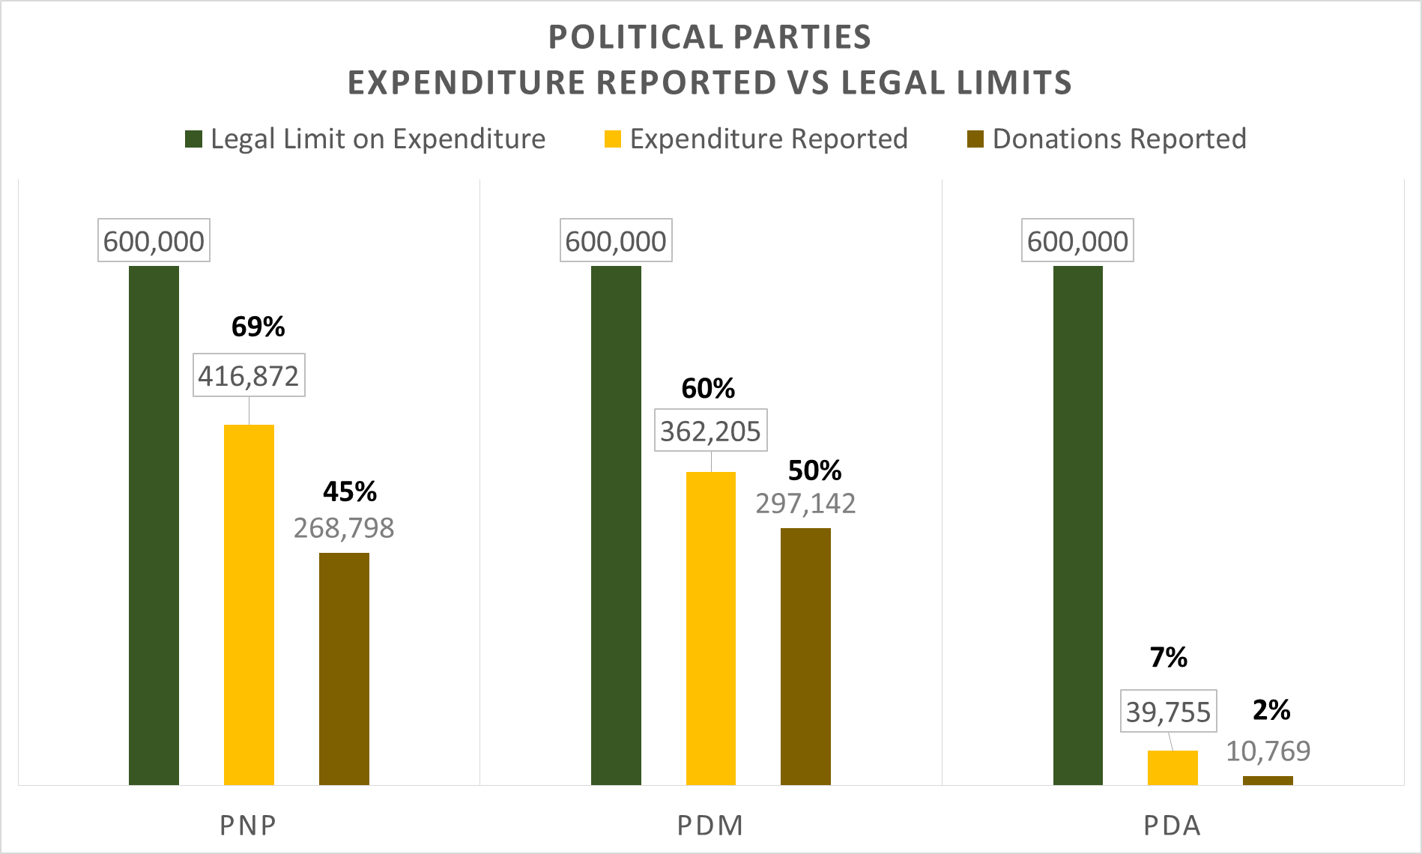The PNP reported expenditure of $416,872 was 69% of the legal expenditure limit of $600,000.

The PDM reported expenditure of $362,205 was 60% of the legal expenditure limit of $600,000.

The PDA reported expenditure of $39,755 was 7% of the legal expenditure limit of $600,000.

See chart to the right and table below.

|  |  |  |  |  |  |
| --- | --- | --- | --- | --- | --- |
| **Political Parties** | **Legal Limit on Expenditure** | **Expenditure Reported** | **Donations Reported** | **Expenditure Reported as a % of Expenditure Limit** | **Donation Reported as a % of Expenditure Limit** |
| PNP | 600,000 | 416,872 | 268,798 | 69% | 45% |
| PDM | 600,000 | 362,205 | 297,142 | 60% | 50% |
| PDA | 600,000 | 39,755 | 10,769 | 7% | 2% |
| **Total** | **1,800,000** | **818,832** | **576,708** | **45%** | **32%** |

When the reported donations are added to the comparison with the legal expenditure limit, the result indicate the PNP donations represents 45% of the expenditure limit, the PDM 50% and the PDA 2%.

Further comparison also indicates the total donations reported by the political parties was $242,124 or 42% lower than the expenditure reported. All three parties reported more expenditure during the period than their reported donations for the period. See table below. Reasons for the variations could be:

1. expenditure reported above donations was funded thru cash already on hand before the election period or
2. there may be unreported donations for the election period.

|  |  |  |  |  |  |
| --- | --- | --- | --- | --- | --- |
| **Political Parties** | **Legal Limit on Expenditure** | **Expenditure Reported** | **Donations Reported** | **Variation (Donation - Expenditure)** | **Variation % (shortfall in donations)** |
| PNP | 600,000 | 416,872 | 268,798 | (148,074) | -55% |
| PDM | 600,000 | 362,205 | 297,142 | (65,063) | -22% |
| PDA | 600,000 | 39,755 | 10,769 | (28,986) | -269% |
| **Total** | **1,800,000** | **818,832** | **576,708** | **(242,124)** | **-42%** |

**Comparison of All Island Independent Candidate Expenditure with legal expenditure limit**

The seven (7) All Island Independent Candidates reported expenditure of $68,256 was 10% of the combined legal expenditure limit of $700,000.

The highest level of expenditure amongst this group was reported by Micheal E Missick with $22,553. This represent 23% of the legal limit. The 2nd highest amount of $20,827 was reported by Sabrina Green which is 21 of the legal limit. Jasmin Walkin reported expenditure of $10,439 which is 10 of the legal limit. The remaining four (4) candidates each reported expenditures 6% or less of the legal limit. See chart and table below.

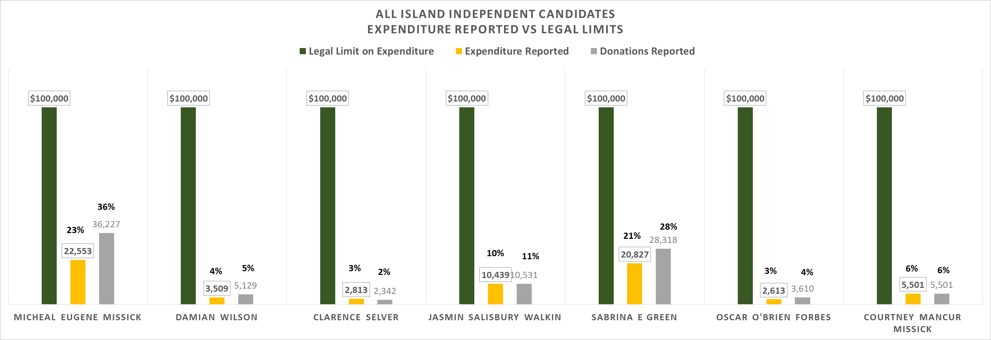

|  |  |  |  |  |  |
| --- | --- | --- | --- | --- | --- |
| **All Island Independent Candidates** | **Legal Limit on Expenditure** | **Expenditure Reported** | **Donations Reported** | **Expenditure Reported as a % of Expenditure Limit** | **Donation Reported as a % of Expenditure Limit** |
| Micheal Eugene Missick | 100,000 | 22,553 | 36,227 | 23% | 36% |
| Damian Wilson | 100,000 | 3,509 | 5,129 | 4% | 5% |
| Clarence Selver | 100,000 | 2,813 | 2,342 | 3% | 2% |
| Jasmin Salisbury Walkin | 100,000 | 10,439 | 10,531 | 10% | 11% |
| Sabrina E Green | 100,000 | 20,827 | 28,318 | 21% | 28% |
| Oscar O'Brien Forbes | 100,000 | 2,613 | 3,610 | 3% | 4% |
| Courtney Mancur Missick | 100,000 | 5,501 | 5,501 | 6% | 6% |
| **Total** | **700,000** | **68,256** | **91,659** | **10%** | **13%** |

When the reported donations are added to the comparison with the legal expenditure limit, the result indicate the All Island Candidates donations represents 13% of the combined expenditure limit of $700,000. Five (5) of the seven (7) candidates reported more donations than expenditure. This suggests that surplus donations are being held by these candidates and will have to be accounted for to the Commission. See table below.

The following scenarios may be reasons for the variance

1. potentially over reporting of donations, or
2. possible understated expenditure

|  |  |  |  |  |  |
| --- | --- | --- | --- | --- | --- |
| **All Island Independent Candidates** | **Legal Limit on Expenditure** | **Expenditure Reported** | **Donations Reported** | **Variation (Donation - Expenditure)** | **Variation %**  **(surplus donation)** |
| Micheal Eugene Missick | 100,000 | 22,553 | 36,227 | 13,675 | 38% |
| Damian Wilson | 100,000 | 3,509 | 5,129 | 1,620 | 32% |
| Clarence Selver | 100,000 | 2,813 | 2,342 | (471) | -20% |
| Jasmin Salisbury Walkin | 100,000 | 10,439 | 10,531 | 92 | 1% |
| Sabrina E Green | 100,000 | 20,827 | 28,318 | 7,491 | 26% |
| Oscar O'Brien Forbes | 100,000 | 2,613 | 3,610 | 997 | 28% |
| Courtney Mancur Missick | 100,000 | 5,501 | 5,501 | 0 | 0% |
| **Total** | **700,000** | **68,256** | **91,659** | **23,403** | **26%** |

**Comparison of District Independent Candidate Expenditure with legal expenditure limit**

The three (3) District Independent Candidates reported expenditure of $34,296 was 38% of the combined legal expenditure limit of $90,000.

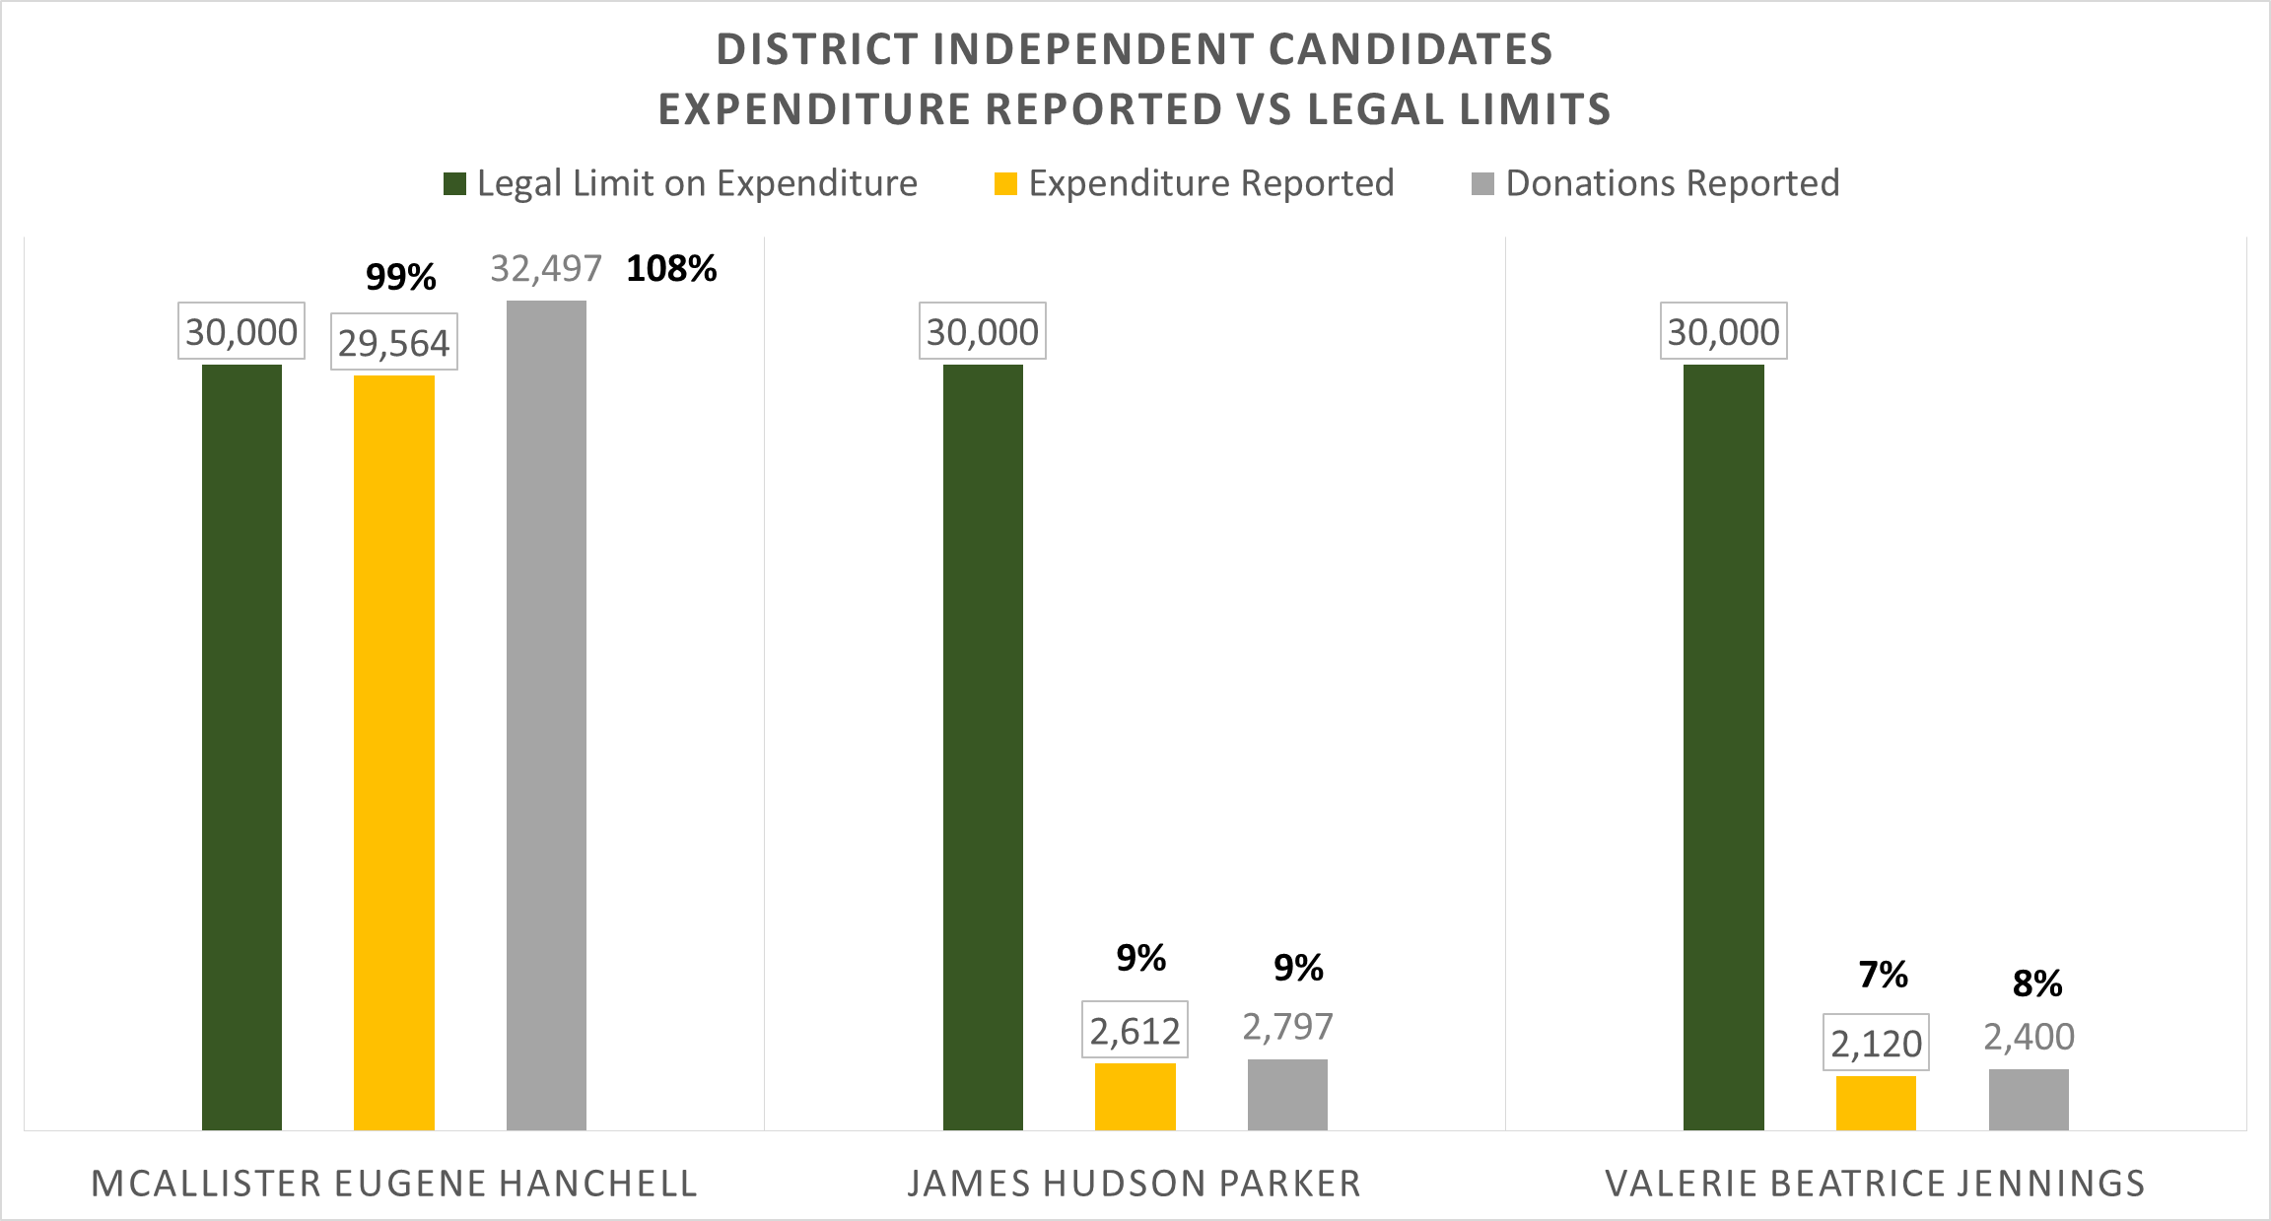The highest level of expenditure reported by a candidate amongst this group was $29,564 and represents 99% of the legal limit. This is the highest percentage use of the legal expenditure limit amongst all the political parties and all the independent candidates.

The other two (2) candidates reported expenditures with 9% or less of the legal limit. See chart and table below.

|  |  |  |  |  |  |
| --- | --- | --- | --- | --- | --- |
| **District Independent Candidates** | **Legal Limit on Expenditure** | **Expenditure Reported** | **Donations Reported** | **Expenditure Reported as a % of Expenditure Limit** | **Donation Reported as a % of Expenditure Limit** |
| McAllister Eugene Hanchell | 30,000 | 29,564 | 32,497 | 99% | 108% |
| James Hudson Parker | 30,000 | 2,612 | 2,797 | 9% | 9% |
| Valerie Beatrice Jennings | 30,000 | 2,120 | 2,400 | 7% | 8% |
| **Total** | **90,000** | **34,296** | **37,695** | **38%** | **42%** |

When the reported donations are added to the comparison with the legal expenditure limit, the result indicate the District Independent Candidates donations represents 42% of the combined expenditure limit of $90,000. All three candidates expenditure was less than the donations they reported. One candidate’s reported donations exceeded their legal spending limit. This suggests there should be surplus donations being held by these candidates and will be accounted for to the Commission. See table below

|  |  |  |  |  |  |
| --- | --- | --- | --- | --- | --- |
| **District Independent Candidates** | **Legal Limit on Expenditure** | **Expenditure Reported** | **Donations Reported** | **Variation (Donation - Expenditure)** | **Variation %** |
| McAllister Eugene Hanchell | 30,000 | 29,564 | 32,497 | 2,934 | 9% |
| James Hudson Parker | 30,000 | 2,612 | 2,797 | 185 | 7% |
| Valerie Beatrice Jennings | 30,000 | 2,120 | 2,400 | 280 | 12% |
| **Total** | **90,000** | **34,296** | **37,695** | **3,399** | **9%** |

**EXPENDITURE REPORTED BY POLITICAL PARTIES**

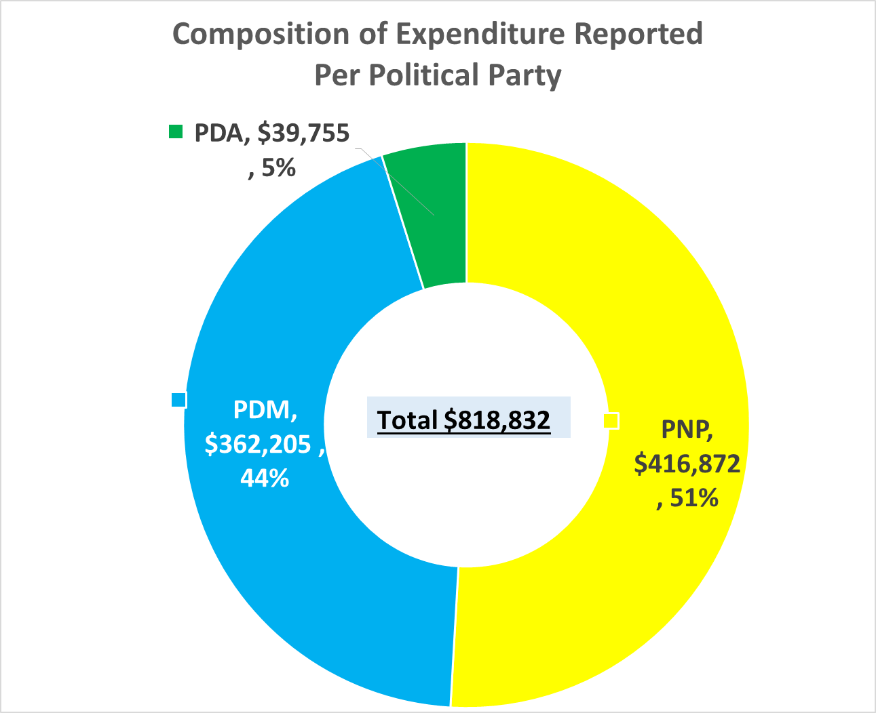**Expenditure Reported by Political Parties**

The total expenditure reported by the three (3) political parties amounted to **$818,832.**

The PNP accounted for 51% of the expenditure reported while the PDM accounted for 44% and the PDA represented 5%. See table and chart below.

|  |  |  |
| --- | --- | --- |
| **Party** | **Expenditure** | **(%)** |
| PNP | 416,872 | 51% |
| PDM | 362,205 | 44% |
| PDA | 39,755 | 5% |
| **Total** | **818,832** | **100%** |

**Composition of Total Expenditure by Political Party**

Expenditure reported by the three (3) political parties were broken down into ten (10) general categories. See table below

|  |  |  |  |  |  |
| --- | --- | --- | --- | --- | --- |
| **Categories of Expenditure** | PNP | PDM | PDA | **Total** | **%** |
| Party Political Broadcasts | 12,000 | 0 | 0 | 12,000 | 1% |
| Advertising and publicity material | 168,767 | 223,700 | 5,868 | 398,335 | 49% |
| Unsolicited material to electors | 0 | 0 | 0 | 0 | 0% |
| Manifesto/party policy documents | 21,109 | 23,651 | 15,774 | 60,534 | 7% |
| Market Research/canvassing | 69,266 | 0 | 0 | 69,266 | 8% |
| Media | 49,455 | 0 | 1,165 | 50,620 | 6% |
| Transport | 6,662 | 10,295 | 3,600 | 20,557 | 3% |
| Rallies and Other Events | 70,081 | 80,999 | 6,754 | 157,834 | 19% |
| Overheads and Administration | 19,532 | 23,560 | 6,594 | 49,686 | 6% |
| Other | 0 | 0 | 0 | 0 | 0% |
| **Total** | **416,872** | **362,205** | **39,755** | **818,832** | **100%** |

**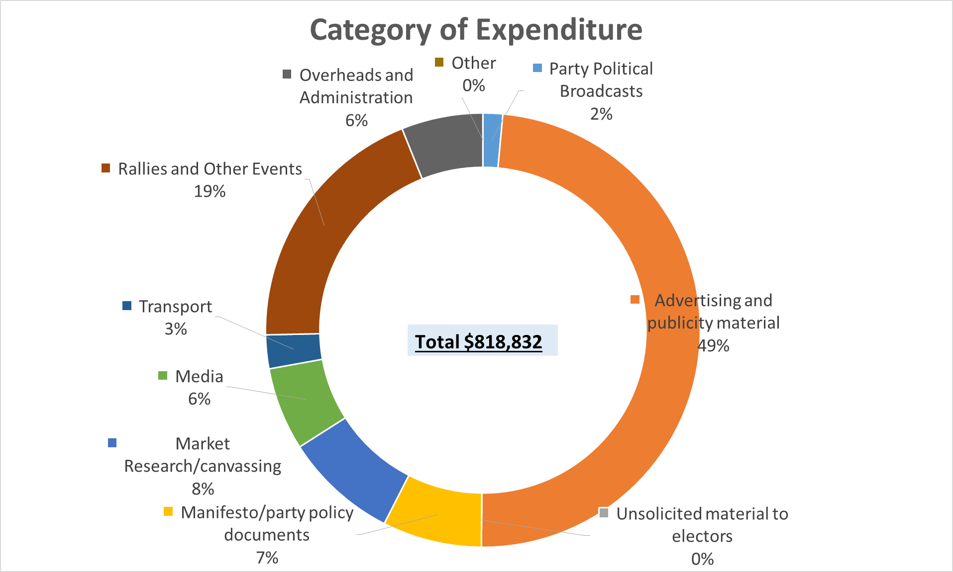*Advertising and publicity material*** accounted for 49% of the total reported expenditure while ***Rallies and Other Events*** represented 19%. These two (2) categories accounted for 68% of the reported expenditure while the remaining eight (8) categories combined for 32%.

Each of these eight (8) categories accounted for 8% or less of the total expenditure. See chart.

**Reported Expenditure by the PNP**

Expenditure reported by the PNP amounted to $416,872 and had expenditure in only 8 categories.

***Advertising and publicity material*** accounted for 40% of the total reported expenditure.

This was followed by ***Market Research/canvassing*** & ***Rallies and Other Events*** *which each accounted for 17% of the amounts reported.*

**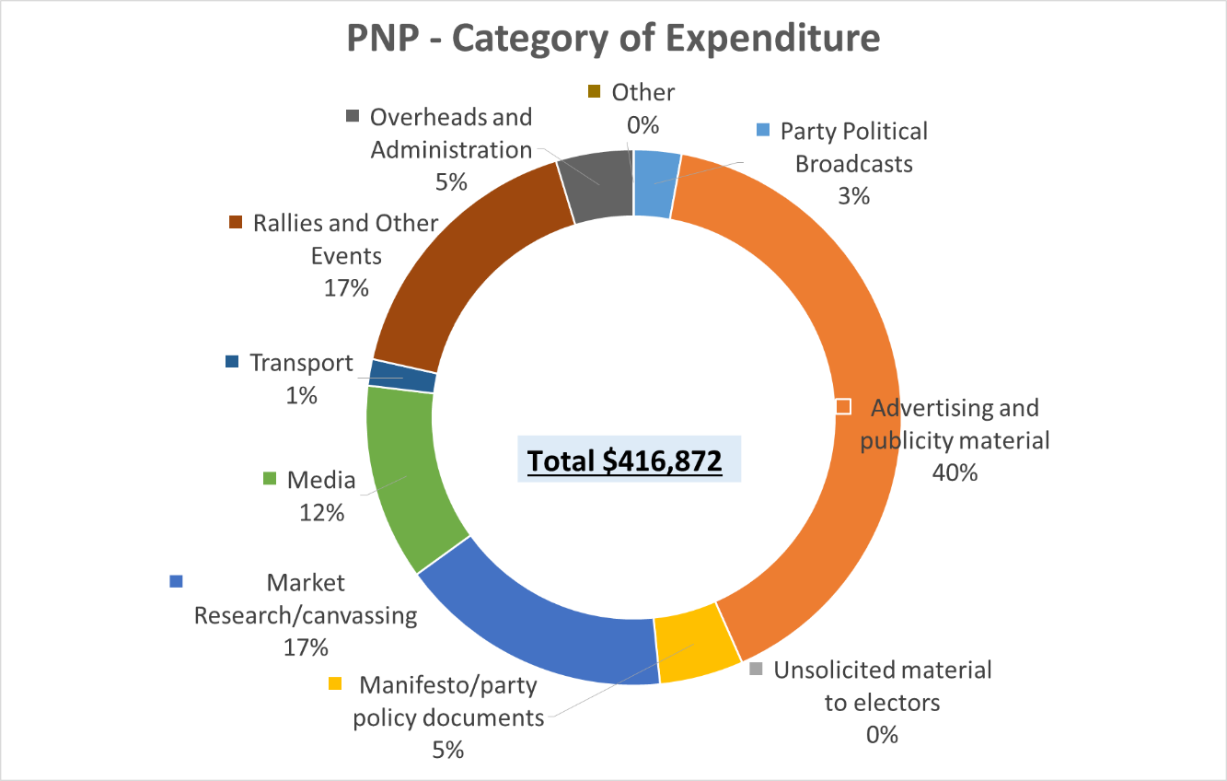*Media***accounted for 12% of the reported expenditure.

These four (4) categories accounted for 86% of the reported expenditure while the remaining four (4) categories combined for 14%.

Each of these four (4) categories accounted for 5% or less of the total expenditure. See chart and table above.

**Reported Expenditure by the PDM**

Expenditure reported by the PDM amounted to $362,205 and had expenditure in only five (5) categories.

***Advertising and publicity material*** accounted for 62% of the total reported expenditure.

This was followed by ***Rallies and Other Events*** *which accounted for 22% of the amounts reported.*

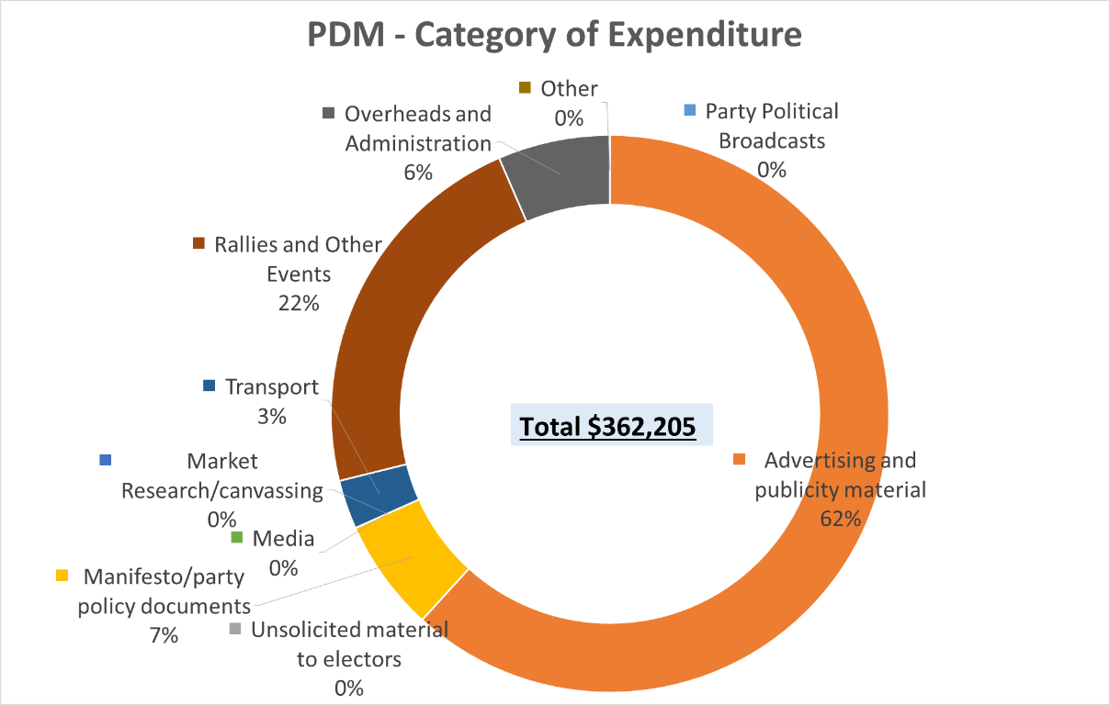These two (2) categories accounted for 84% of the reported expenditure while the remaining three (3) categories combined for 16%. Each of these three (3) categories accounted for 7% or less of the total expenditure. See chart and table.

**Reported Expenditure by the PDA**

Expenditure reported by the PDA amounted to $39,755 and had expenditure in six (6) categories.

***Mannifesto/party policy documents*** accounted for 40% of the total reported expenditure.

This was followed by ***Rallies and Other Events*** and ***Overheads and Administration*** which each accounted for 17% of the amounts reported.

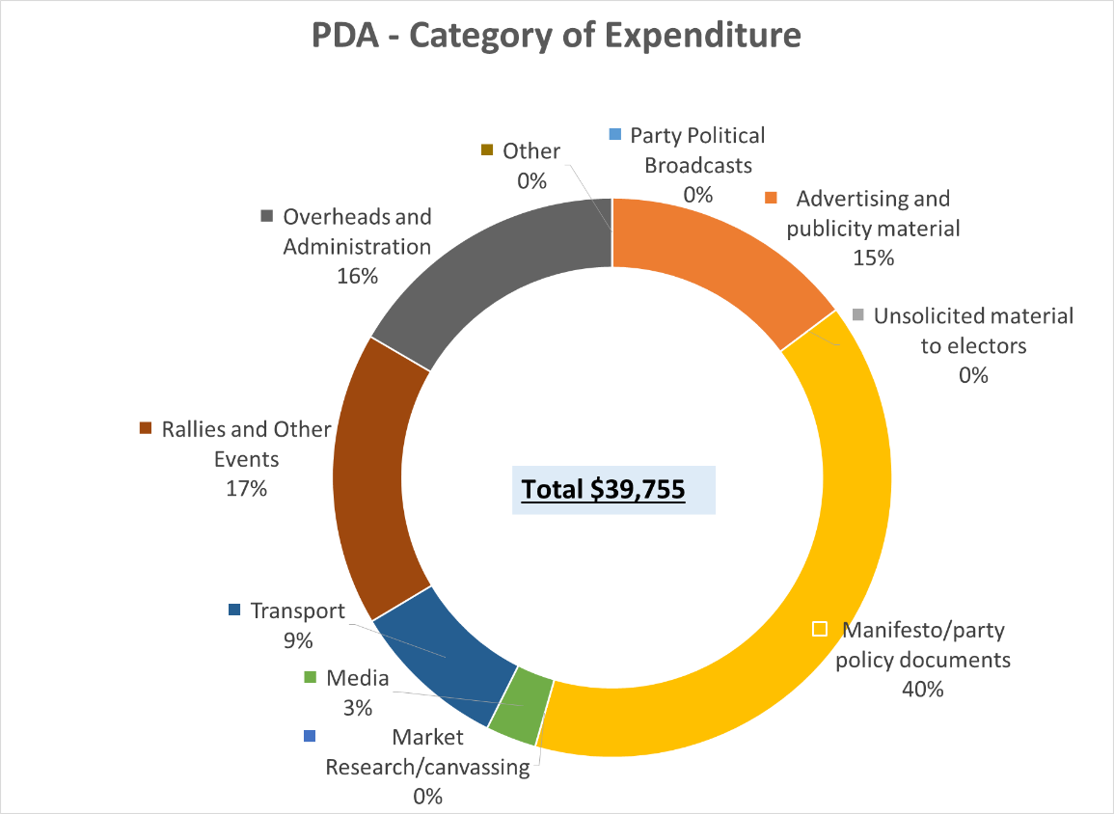***Advertising and publicity material***accounted for 15% of the reported expenditure.

These four (4) categories combined accounted for 88% of the reported expenditure while the remaining two (2) categories combined for 12%. Each of these two (2) categories accounted for 9% or less of the total expenditure. See chart and table.

**EXPENDITURE REPORTED BY INDEPENDENT CANDIDATES**

**Total Expenditure Reported by Independent Candidates**

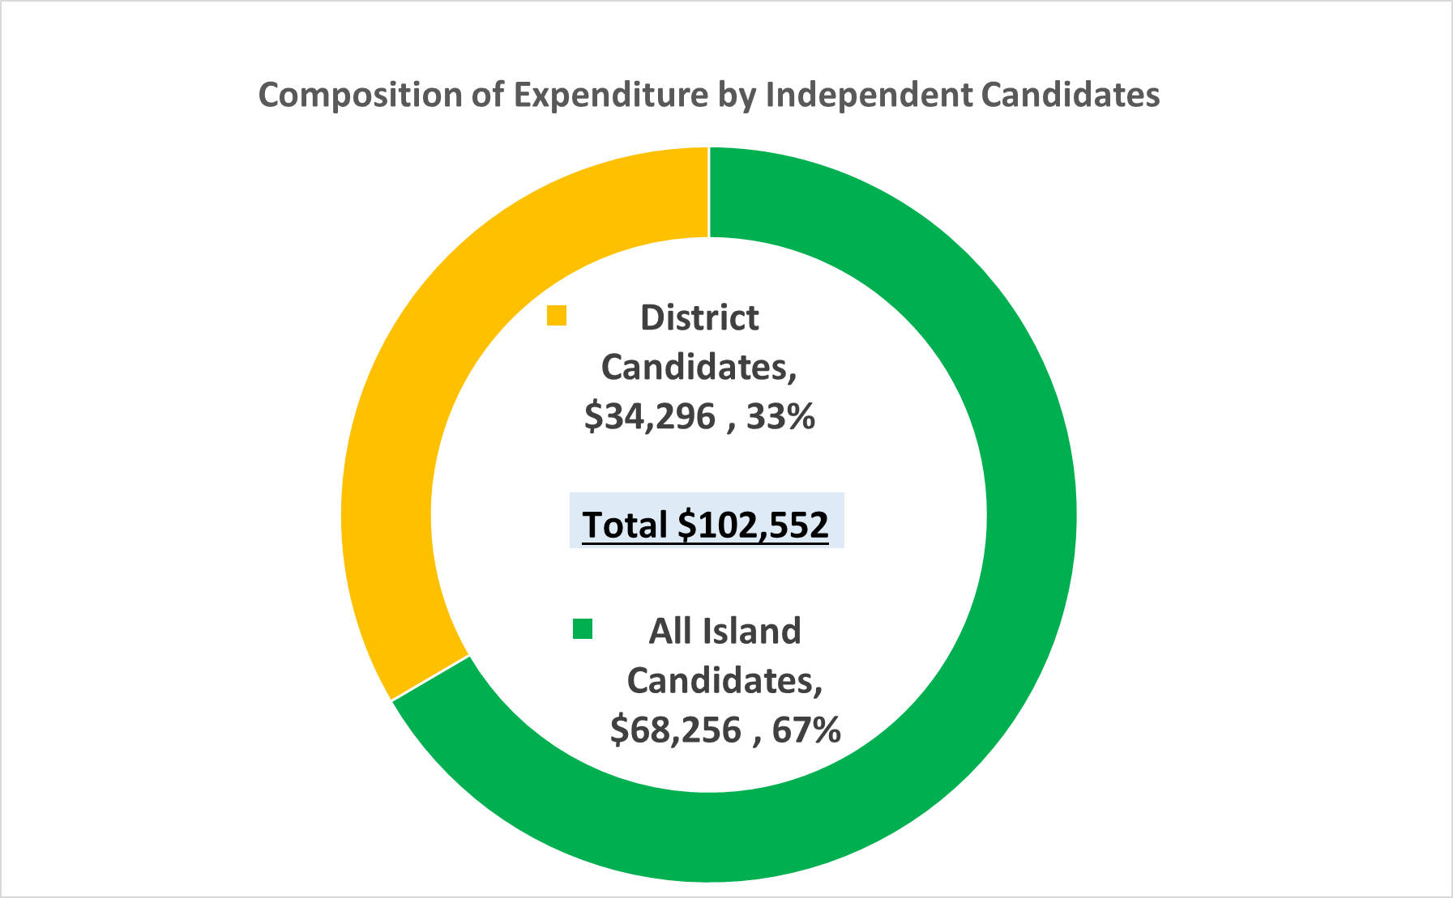

Total expenditure reported by the ten (10) Independent Candidates amounted to **$102,551**.

All Island Candidates accounted for 67% of the reported expenditure while District Candidates reported expenditure amounted to 33%. See table and chart below.

|  |  |  |
| --- | --- | --- |
| **Independent Candidate** | **Expenditure Reported** | **%** |
| All Island Candidates | 68,256 | 67% |
| District Candidates | 34,296 | 33% |
| **Total** | **102,552** | **100%** |

**Composition of Total Expenditure by each Candidate**

Amongst all the ten (10) Independent Candidates, McAllister Hanchell accounted for 29% of the total expenditure reported by Independent Candidates. This was followed by Michael Missick with 22%, Sabrina Green 20% and Jasmin Walkin 10%.

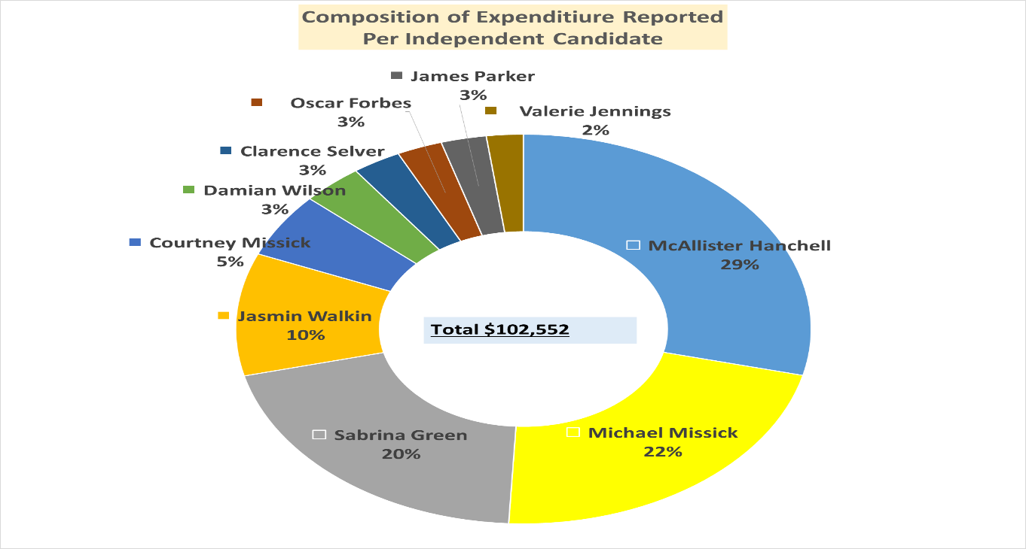These four (4) candidates combined, accounted for 81% of the total expenditure reported by the Independent Candidates.

The remaining six (6) candidates accounted for a combined 19% and each represented 5% or less of the total expenditure reported for Independent Candidates. See table and chart.

**Composition of Expenditure by All Island Independent Candidates**

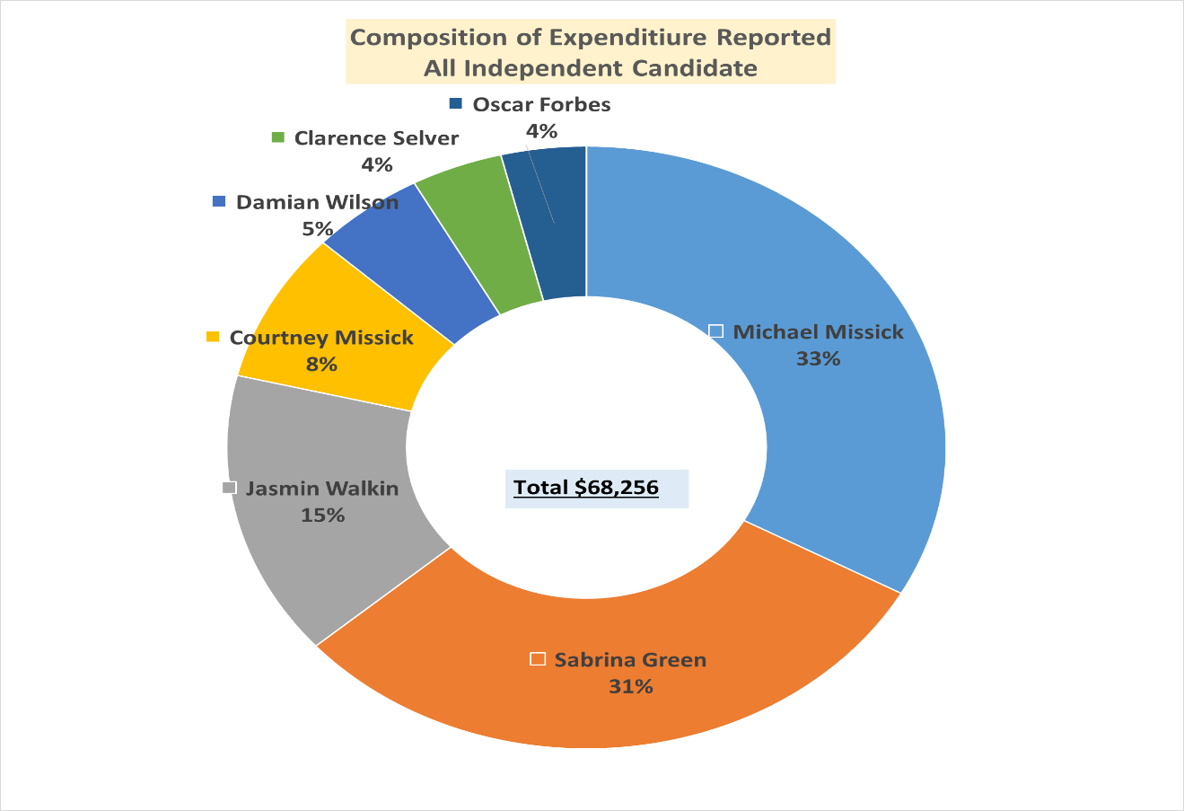The seven (7) All Island Independent Candidates reported campaign expenditure amounting to $68,256.

Amongst all the seven (7) All Island Independent Candidates, Michael Missick accounted for 33% of the total expenditure reported. This was followed by Sabrina Green 31% and Jasmin Walkin 15%.

These three (3) candidates combined, accounted for 79% of the total expenditure reported by the All Island Independent Candidates.

The remaining four (4) candidates accounted for a combined 21% and each represented 8% or less of the total expenditure reported for All Island Independent Candidates. See table and chart.

|  |  |  |  |  |
| --- | --- | --- | --- | --- |
| **All Island Candidate** | **Expenditure** | **Cumulative Expenditure** | **Total (%)** | **Cumulative %** |
| Michael Missick | 22,553 | 22,553 | 33% | 33% |
| Sabrina Green | 20,827 | 43,380 | 31% | 64% |
| Jasmin Walkin | 10,439 | 53,819 | 15% | 79% |
| Courtney Missick | 5,501 | 59,320 | 8% | 87% |
| Damian Wilson | 3,509 | 62,830 | 5% | 92% |
| Clarence Selver | 2,813 | 65,643 | 4% | 96% |
| Oscar Forbes | 2,613 | **68,256** | 4% | **100%** |
| **Total** | **68,256** |  | **100%** |  |

**Composition of Expenditure by District Independent Candidates**

The three (3) District Independent Candidates reported campaign expenditure amounting to $34,296. McAllister Hanchell accounted for 86% of the total expenditure while James Parker accounted for 8% and Valerie Jennings 6%. See table and chart.

|  |  |  |  |  |  |
| --- | --- | --- | --- | --- | --- |
| **District Independent Candidate** | **Electoral District** | **Expenditure** | **Cumulative Expenditure** | **Total (%)** | **Cumulative %** |
| McAllister Hanchell | ED3 | 29,564 | 29,564 | 86% | 86% |
| James Parker | ED10 | 2,612 | 32,176 | 8% | 94% |
| Valerie Jennings | ED2 | 2,120 | **34,296** | 6% | **100%** |
| **Total** |  | **34,296** |  | **100%** |  |

